**Po Leung Kuk Celine Ho Yam Tong College**

Information and Communication Technology

2024 SBA

Name: Lai Chun Kit

Class: 6B

Class No.: 11

Title: *Jaygo’s Computer – a computer shopping site*

Task 1 (Design & Implementation)

Submission date: *03/12/2023*

Table of contents

**Table of contents** 2

Introduction 3

Background 3

Trend 4

Customer-to-customer (C2C) 5

Business-to-business (B2B) 6

Business-to-customer (B2C) 7

Website Design 9

Features for a Good Shopping Site 9

Overview for Jaygo’s Computer 15

Development Tools 28

Programming languages 28

Modules used in the project 35

Implementation 36

Responsive Layouts 36

Templates 38

Showing latest and popular products 40

Thumbnail 41

Store page searching, sorting and filtering 43

Login and registration 45

Verification 48

Validation 49

Admin panel functions 50

Comment and Rating 51

Shopping cart 53

Payment 54

Different Languages 55

Database 57

Introduction

Background

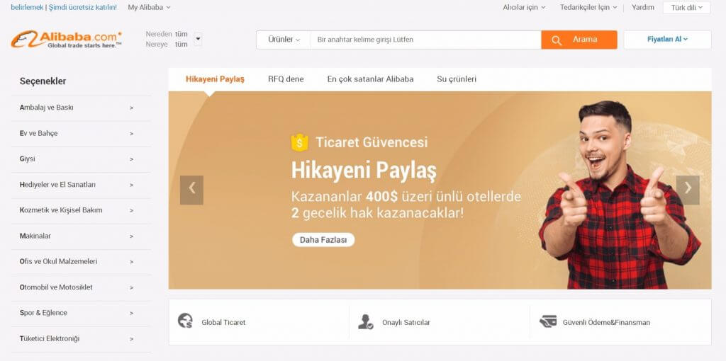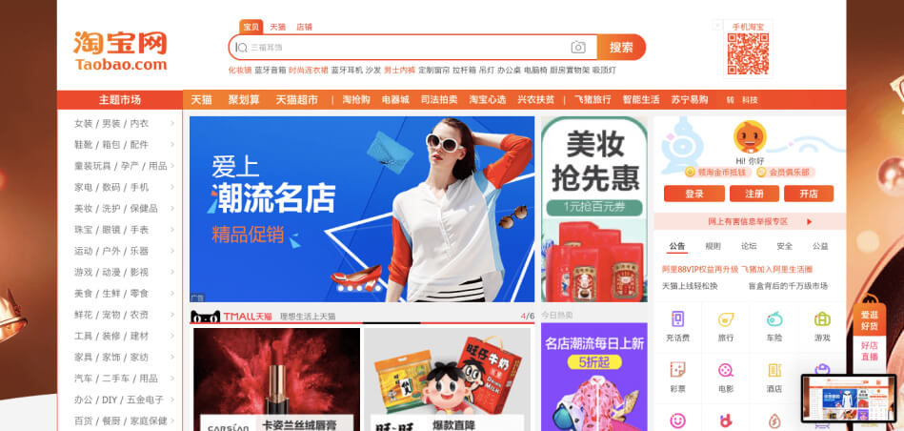Online shopping is a form of electronic commerce which allows consumers to directly buy goods or services from a seller over the Internet using a web browser or a mobile app. Consumers find a product of interest by visiting the website of the retailer directly or by searching among alternative vendors using a shopping search engine, which displays the same product's availability and pricing at different e-retailers. As of 2020, customers can shop online using a range of different computers and devices, including desktop computers, laptops, tablet computers and smartphones. An online shop evokes the physical analogy of buying products or services at a regular "brick-and-mortar" retailer or shopping centre; the process is called business-to-consumer (B2C) online shopping. When an online store is set up to enable businesses to buy from another businesses, the process is called business-to-business (B2B) online shopping. A typical online store enables the customer to browse the firm's range of products and services, view photos or images of the products, along with information about the product specifications, features and prices. Online stores usually enable shoppers to use "search" features to find specific models, brands or items. Online customers must have access to the Internet and a valid method of payment in order to complete a transaction, such as a credit card, an Interact-enabled debit card, or a service such as PayPal. For physical products (e.g., paperback books or clothes), the e-tailer ships the products to the customer; for digital products, such as digital audio files of songs or software, the e-tailer usually sends the file to the customer over the Internet. The largest of these online retailing corporations are Taobao, Alibaba, Amazon.com, and eBay.[1]

Figure 2 Alibaba

Figure Taobao

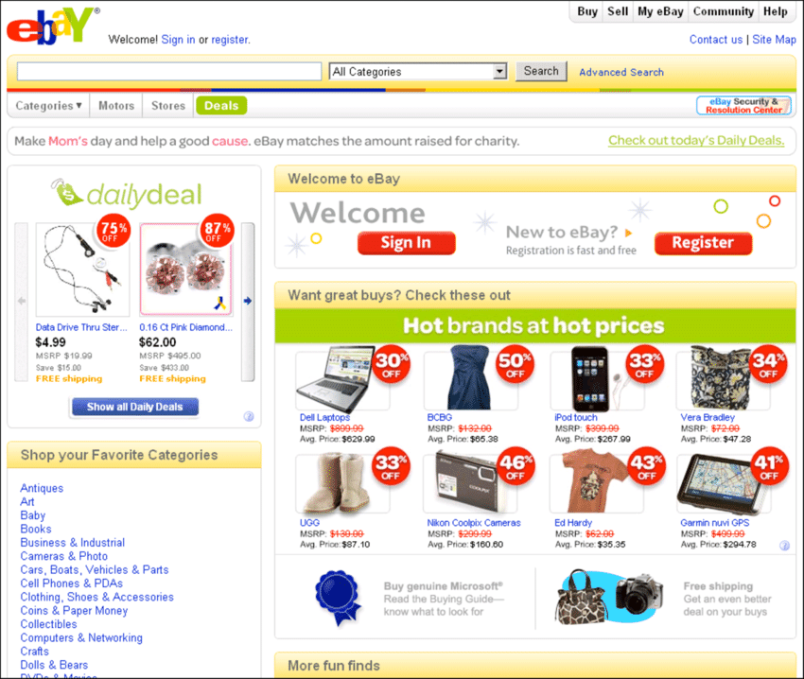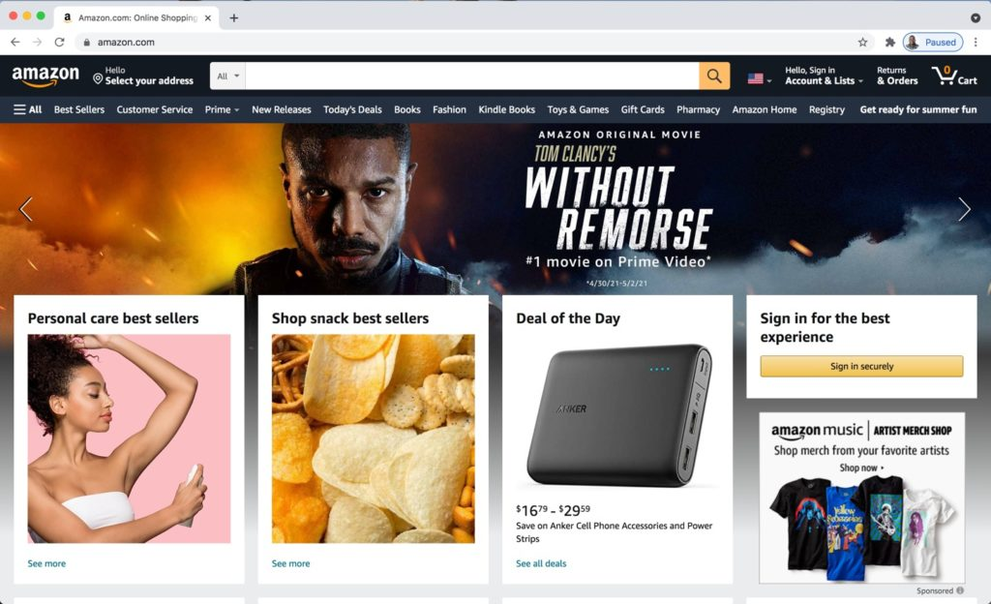

Figure 4 Other examples

Figure 3 Other examples

Trend

Over the last few years, e-commerce has become an indispensable part of global retail. Like many other industries, buying and selling goods has undergone a substantial transformation following the advent of the internet, and thanks to the ongoing digitalization of modern life, consumers all over the world now profit from the perks of online transactions. As global internet access and adoption rapidly increase, with over five billion internet users worldwide, the number of people making purchases online is ever-increasing. In 2022, retail e-commerce sales were estimated to exceed 5.7 trillion U.S. dollars worldwide, and this figure is expected to reach new heights in the coming years.[2]

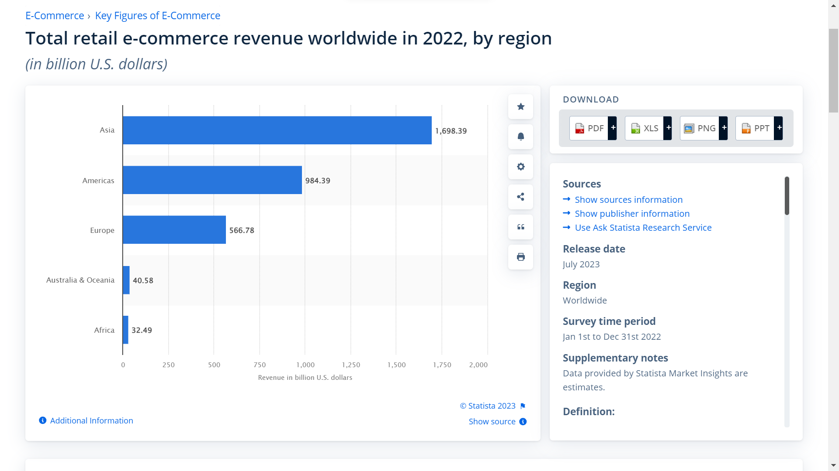

Figure 5

This indicates that online shopping is getting much more popular. Creating a shopping site can maximize the revenue of a company.

Customer-to-customer (C2C)

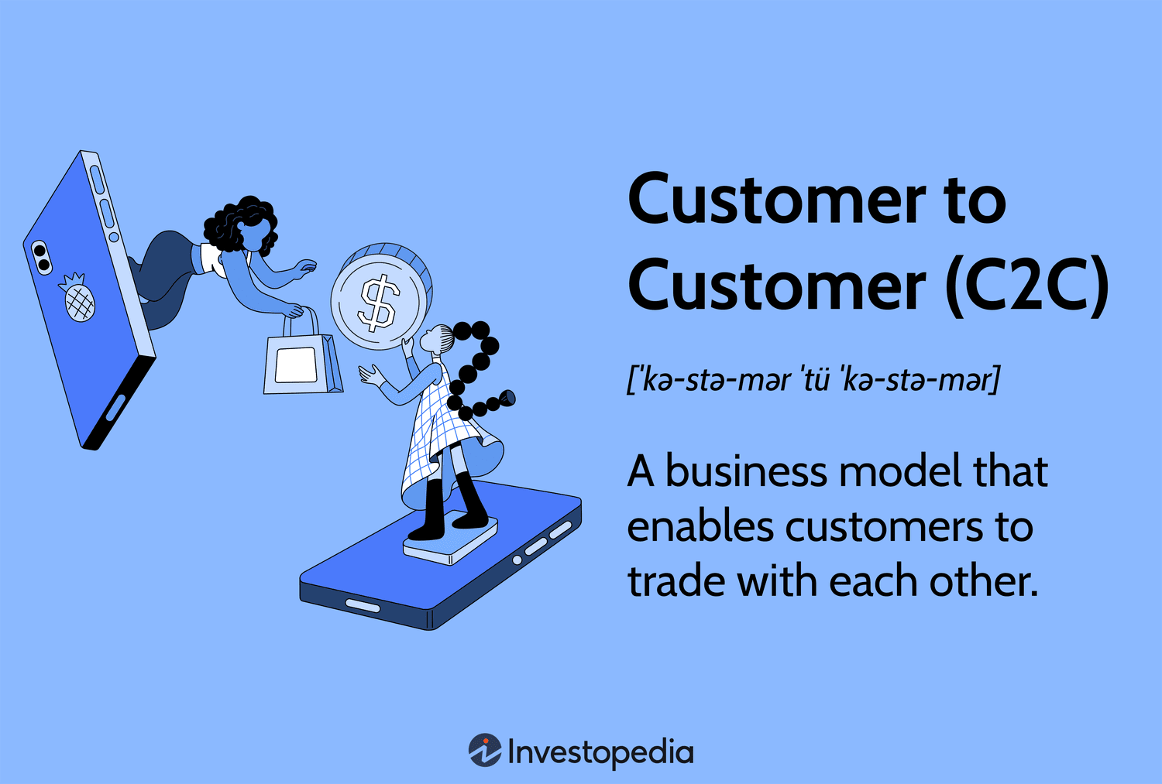Customer to customer (C2C or consumer to consumer) markets provide a way to allow customers to interact with each other. Traditional markets require business to customer relationships, in which a customer goes to the business in order to purchase a product or service. In customer to customer markets, the business facilitates an environment where customers can sell goods or services to each other

Figure 6

Most C2C websites, such as eBay, have both streamlined and globalized traditional person-to-person trading, which was usually conducted through such forms as garage sales, collectibles shows, flea markets and more, with their web interface. This facilitates easy exploration for buyers and enables the sellers to immediately list an item for sale within minutes of registering. When an item is listed on a C2C site, a nonrefundable insertion fee is charged based on the seller's opening bid on the item. Once the auction is completed, a final value fee is charged. This fee generally ranges from 1.25 percent to 5 percent of the final sale price.

After the C2C site sets up the system in which bids could be placed, items can be put up for sale, transactions can be completed, seller fees are charged, and feedback can be left, while the C2C site stays in the background. For example, at the end of an auction, the C2C site notifies the buyer via e-mail that he or she has won. The C2C site also e-mails the seller to report who won and at what price the auction finished. At that point it's up to the seller and buyer to finish the transaction independently of the C2C site. C2C sites make money by charging fees to sellers. Although it's free to shop and place bids, sellers place fees to list items for sale, add on promotional features, and successfully complete transactions.

Many C2C sites have expanded and developed existing product categories by introducing category-specific bulletin boards and chat rooms, integrating category-specific content, advertising its service in targeted publications and participating in targeted trade shows. eBay specifically has also broadened the range of products that it offers to facilitate trading on the site, including payment services, shipping services, authentication, appraisal, vehicle inspection and escrow services. Specialty marketplaces have also been added to serve the specialized needs of buyers and sellers. For example, eBay Motors serves the automotive marketplace, including vehicles, parts and accessories; and Half.com (now closed) was focused on providing a fixed-price trading environment, initially for books music, videos and video games. There are various platforms that Consumer-to-consumer e-commerce is taking place on, such as social media (e.g. Facebook, Reddit), advertisement websites (e.g. Craigslist) and online auction sites (e.g. eBay).[3]

Figure 7 ebay

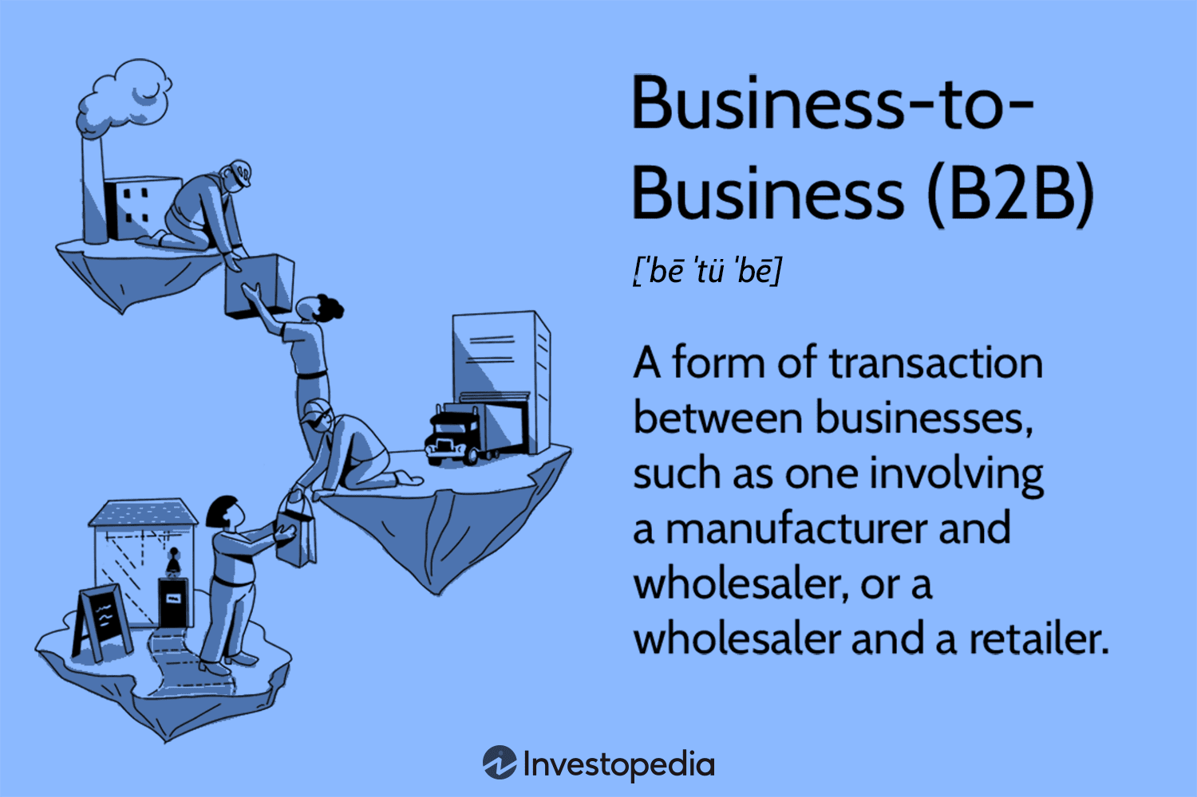Business-to-business (B2B)

Figure 8

Business-to-business (B2B or, in some countries, BtoB) is a situation where one business makes a commercial transaction with another. This typically occurs when:

* A business is sourcing materials for their production process for output (e.g., a food manufacturer purchasing salt), i.e. providing raw material to the other company that will produce output.
* A business needs the services of another for operational reasons (e.g., a food manufacturer employing an accountancy firm to audit their finances).
* A business re-sells goods and services produced by others (e.g., a retailer buying the end product from the food manufacturer).

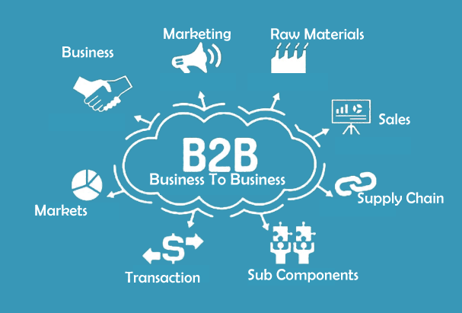Business-to-Business companies represent a significant part of the United States economy. This is especially true in firms of 500 employees and above, of which there were 19,464 in 2015, where it is estimated that as many as 72% are businesses that primarily serve other businesses.[2] One possible argument of economics to explain the levels of Business-to-Business activity is that it allows for business segmentation.[3] B2B is often contrasted with business-to-consumer (B2C) trade. [4]

Figure 9

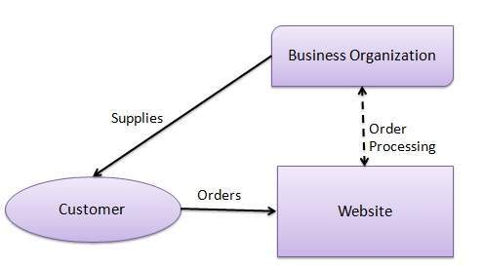Business-to-customer (B2C)

Figure 10

Business-to-consumer (B2C), or direct-to-consumer, is the most common e-commerce model. It deals in electronic business relationships between businesses—both producers and service providers—with end consumers. Many people like this method of e-commerce as it allows them to shop around for the best prices, read customer reviews, and often find different products that they would not otherwise be exposed to in the physical retail world. This e-commerce category also enables businesses to develop a more personalized relationship with their customers.

Anything one buys online as a consumer is done as part of a B2C transaction. The decision-making process for a B2C purchase is much shorter than a business-to-business (B2B) purchase, especially for items that have a lower value, thus having a shorter sales cycle. B2C businesses therefore typically spend less marketing dollars to make a sale but also have a lower average order value and less recurring orders than their B2B counterparts. B2C innovators have leveraged technology like mobile apps, native advertising and re-marketing to market directly to their customers and make their lives easier in the process.

Examples of B2C businesses are everywhere: exclusively-online retailers include Newegg, Overstock.com, Wish, and ModCloth.



Figure 11



Figure 12



Figure 13

The advantages of B2C e-commerce include:

Unlimited marketplace: The marketplace is unlimited, enabling the customers to explore and shop at their convenience. We can check on the desired product from home, offices and anywhere else without any time restrictions. Products can be purchased from around the world. It represents the breaking of international barriers, giving people the opportunity to purchase products virtually;

Lower costs of doing business: B2C has reduced several business components including employees, purchasing cost, mailing confirmations, phone calls, data entry and the requirement for opening stores with physical existence. This has reduced transaction costs for customers;

Business administration made easier: It has made it easier to record store inventory, shipment, logs and overall business transactions compared with traditional methods of business administration. These calculations are now occurring automatically. Moreover, real-time updates can be provided, through which any issues can be flagged;

More efficient business relationships: Building new and improved associations with the dealers and suppliers;

Workflow automation: This process enables the shipping of products in a timely manner. Furthermore, it automatically adjusts stock levels and figures out location availability. It includes highly reliable security systems, with step by step verification, account entry and admiration mode to look after business transactions. The third-party direct sales are backed up with familiar banking and accounting features that enable businesses to reach out to vendors and perform internal business transactions accordingly.[5]

Website Design

Features for a Good Shopping Site

User-friendly

Ensuring a shopping site is user friendly is essential. A user friendly interface should be effortless to navigate saving users time and effort in finding the products they desire. This involves having an concise menu, effective search and filtering tools that make product discovery easier well as well organized categories that make sense to the average shopper. The design should feel intuitive requiring clicks to reach desired destinations. Additionally, in todays mobile oriented era having a design that's mobile friendly is crucial. It should not look visually appealing. Also function seamlessly across different screen sizes and devices. By prioritizing ease of use we can enhance customers shopping experiences leading to increased satisfaction and repeat visits.

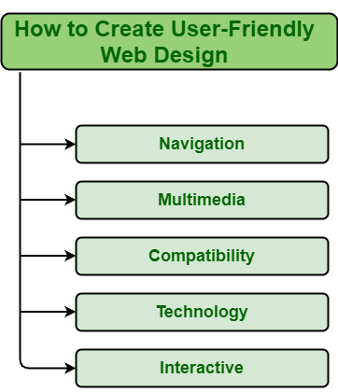

Figure 14

High Quality Images and Descriptions

Having high quality images and comprehensive product descriptions is crucial for a shopping website. They serve as a substitute for the hands on experience one would have in a store. The images should be crystal clear with resolution and captured from various angles to give customers a complete view of the product. As for the descriptions they need to be detailed providing all the information, about the products features, specifications and how it can be used. It's important to address questions that customers may have before making a purchase. This level of transparency helps establish trust with customers assists them in their decision making process and minimizes returns resulting from expectations.

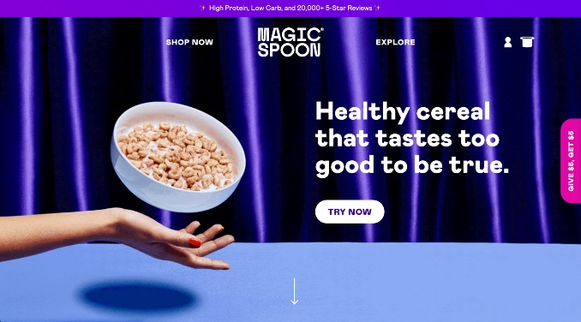

Figure 15

Secure and Diverse Payment Options

Security and payment options are essential for a good online shopping site. Customers need to feel confident that their important information is being handled properly. Secure payment methods such as SSL encryption should be used. Additionally, different payment options are offered which, make use of a wider audience. While credit and debit cards are the norm, alternatives such as PayPal, Apple Pay, or cryptocurrency may appeal to those seeking additional convenience or privacy Not necessarily a stable and secure payment system for a consumer’s purchases experience is not only great but also reinforces trust in the website.

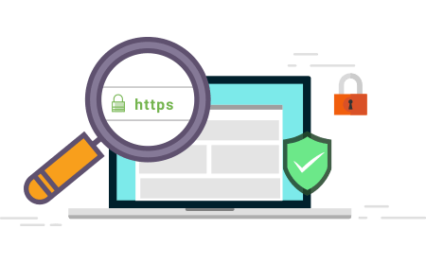

Figure 16

Reviews and Ratings

Customer reviews and ratings are affected by the online shopping experience. They provide social proof, which can significantly sway a potential customer’s purchasing decision. Reviews provide real-life experiences from previous customers, adding some authenticity and credibility to the product. They can highlight a product’s pros and cons, and offer insights that may not be captured in a product description. Ratings provide a quick, in-depth view of a product’s overall quality according to past customers. Together, research and ratings can help consumers make informed decisions, increasing their confidence in their purchases.

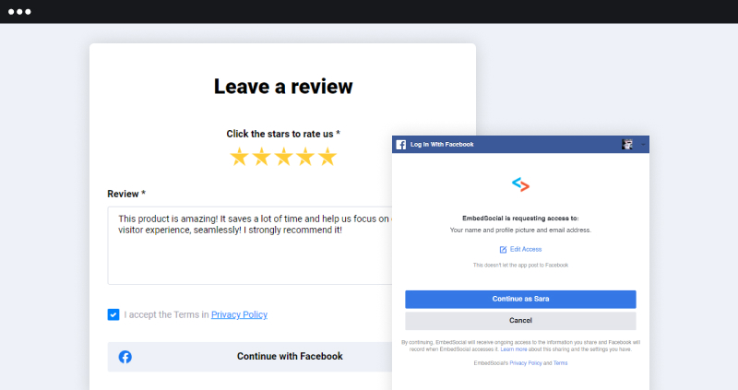

Figure 17 Example

Easy Checkout Process

The checkout process is the final step in converting a site visitor into a customer. A good online shopping site should make this process as easy and efficient as possible. Ideally, it should include a page where customers can view their order, enter their shipping details, choose a payment method, and complete their purchase. The ability to store this information for future orders can greatly simplify the process. The easy checkout process reduces the likelihood of cart abandonment, a common issue in online shopping.

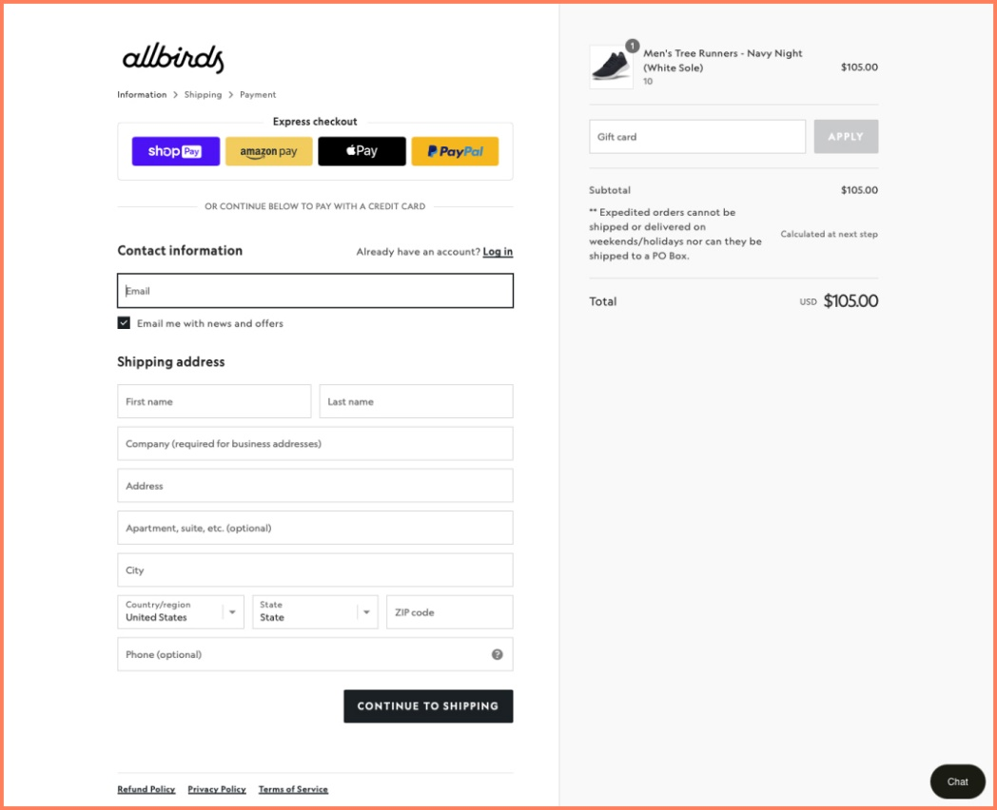

Figure 18 Example

Reliable customer service

Reliable customer service can greatly enhance a business’s reputation and the customer’s overall experience. This includes providing easy-to-find contact information and multiple support channels, such as email, chat and phone service. A comprehensive FAQ or Help Centre to answer frequently asked questions can also be useful. Good customer service not only solves problems, it builds long-term relationships with customers, and encourages repeat business.

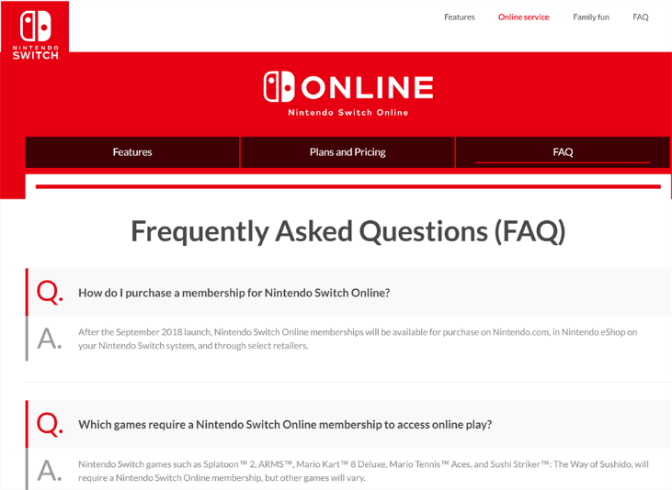

Figure 19 FAQ Example

Return and Refund Policy

A clear and fair return and refund policy is the hallmark of a good online shopping site. It should be simple and logical, indicating where returns are accepted, how returns are issued, and how returns are issued This policy gives customers the confidence to buy, knowing that if the product does not match what they are expected to be reliable.

Privacy Policies and Terms of Service

Privacy policies and terms of service are important legal documents that protect businesses and consumers. It should be clearly described and easily accessible from any page on the website. A privacy policy should outline how customer data is collected, stored and used, while the terms of service detail the rights and responsibilities when using the website These documents make it clear and ensures that the user’s rights are respected.

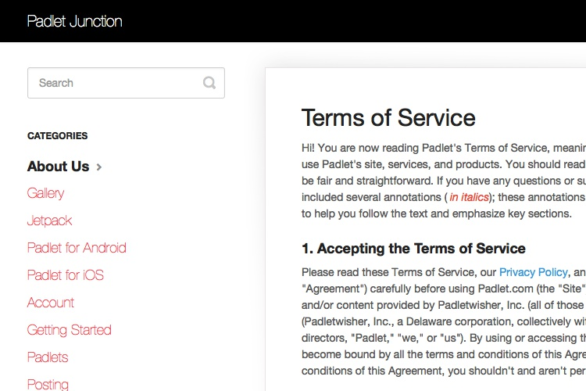

Figure 20

Personalized experience

A personalized shopping experience can dramatically increase customer engagement and satisfaction. By analysing user behaviour and data, the website can offer product recommendations, generate future purchase preferences, and generate reviews and purchase histories These products make shopping easier and more enjoyable for the user, increasing loyalty and sales.

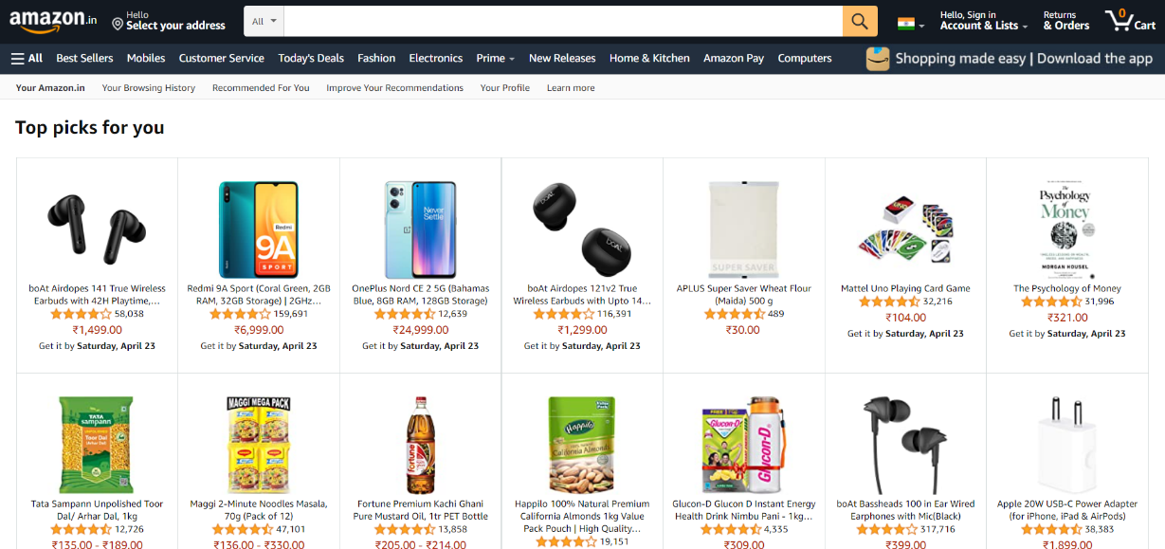

Figure 21

Promotions and deals

Regular promotions and deals can attract customers and drive sales. An effective shopping centre should have a regularly updated deals page and allow users to sign up for promotional emails or notifications. Loyalty or rewards programs can also encourage repeat purchases by offering discounts or special benefits to frequent customers. These products create a sense of value and exclusivity, making customers feel like they are getting more for their money. Additionally, promotions and links can also be marketing tools, encouraging customers to expand on the great deals they find on your site.

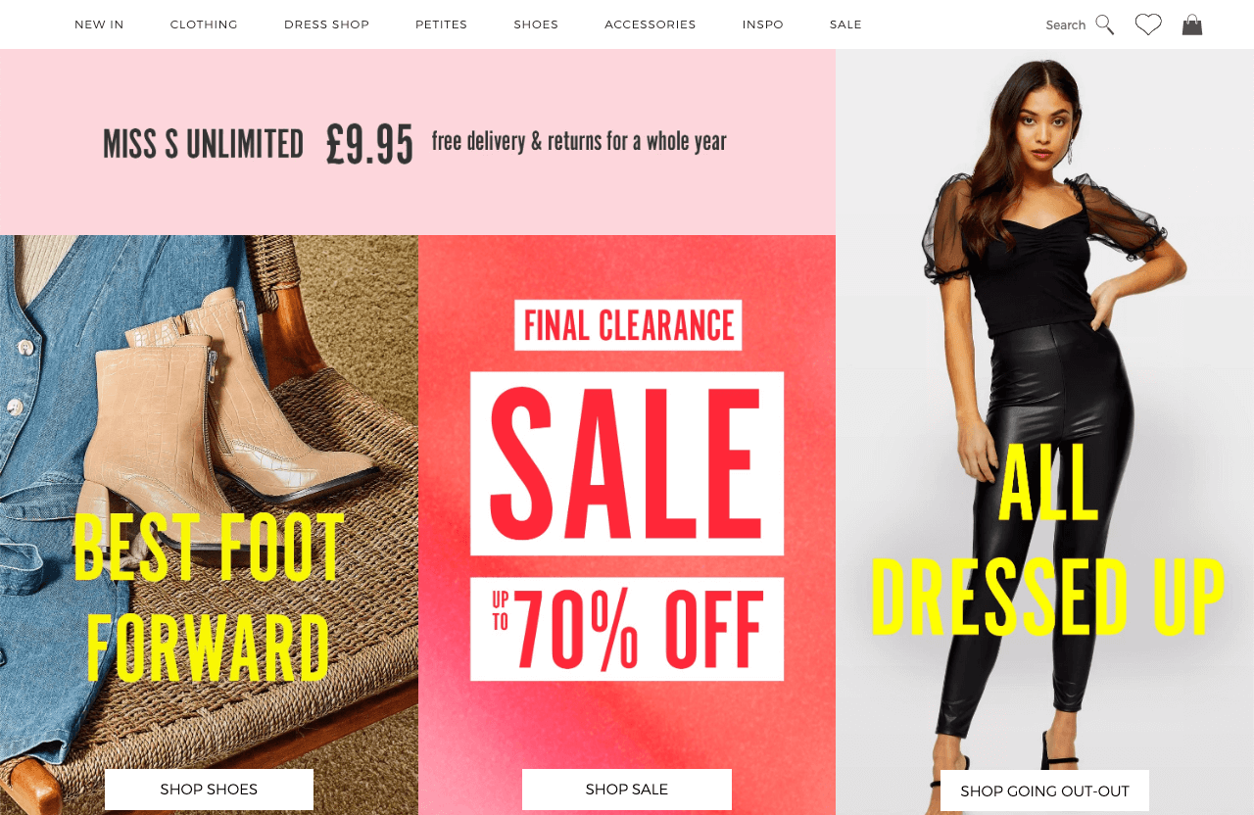

Figure 22

Ease of use

Ease of use is a key feature of any shopping destination. The user-friendly interface is easy to navigate, reducing the time and effort required to search for desired features. This means clear and concise menus, effective search and filtering tools to facilitate product discovery, and well-organized categories that make sense to the average consumer Must that the system is intuitive, with few clicks to get you to the destination. Additionally, in an era of increasing mobile commerce, it is important to have a mobile-friendly system. Not only does it have to look good but it has to work well on larger screens and different devices. All of this ease of use can enhance the customer’s shopping experience, leading to greater satisfaction and repeat visits.

Shipping details

Clear shipping details are another important feature for any online shopping site. This should include shipping costs, delivery times, and details of the locations or countries the location ships to. It can meet the needs of customers by offering a wide range of shipping options such as standard, express and international shipping. Some sites even offer free shipping on orders over a certain amount, which can greatly incentivize customers to increase the price of their orders. Transparent details about shipping can help prevent misunderstandings and customer dissatisfaction, leading to a smoother shopping experience.

Account creation and management

The ability for customers to create their own accounts can dramatically improve their shopping experience. The account allows customers to store their shipping and payment information for faster purchases in the future. It can also enable features such as order tracking, purchase history analysis, and personalized wear recommendations. Account management tools should be easy to use, allowing customers to update their information, review their order history and manage their preferences at any time. This feature can increase customer convenience and loyalty, encouraging them to return to your website for future purchases.

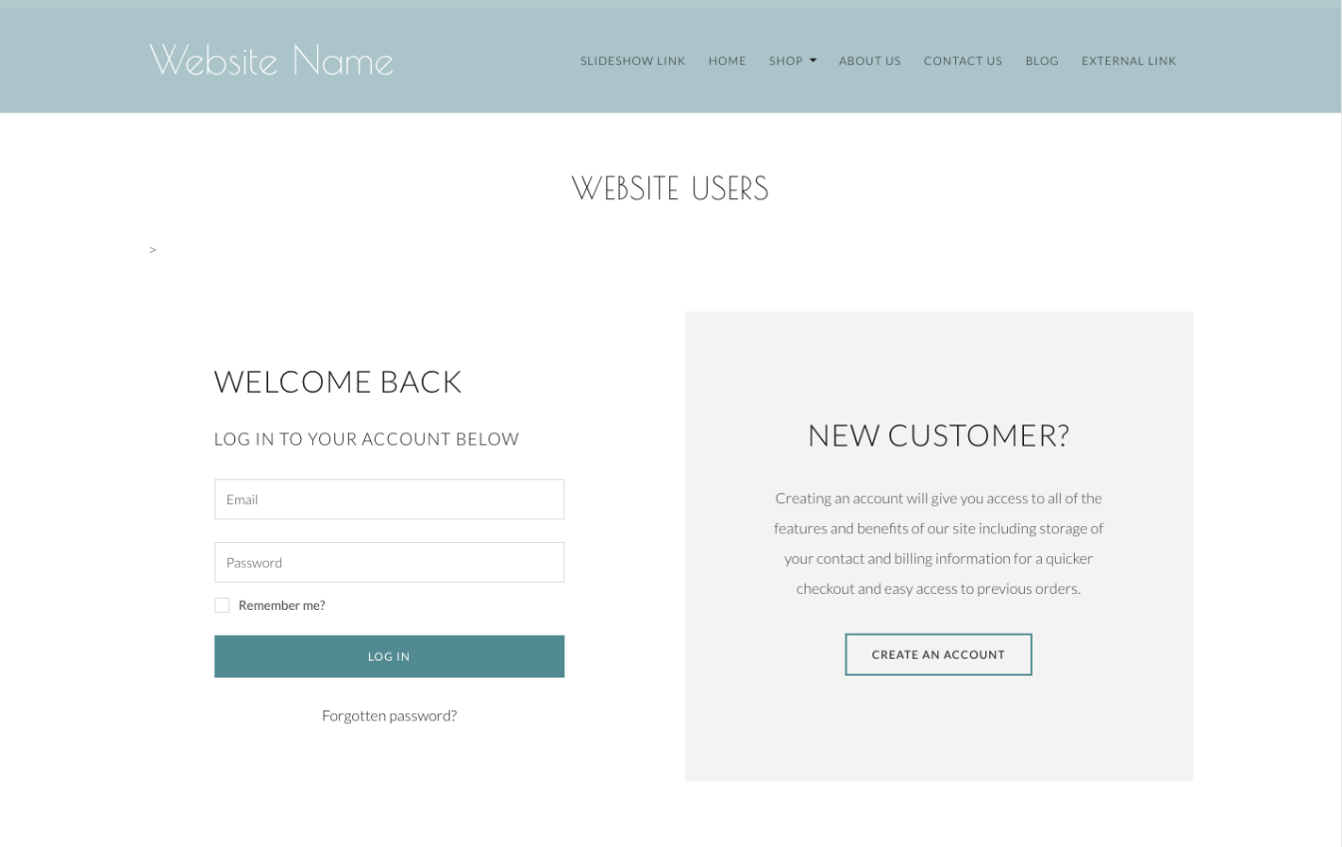

Figure 23

**Overview for Jaygo’s Computer**

Template

The template is written in HTML5, as indicated by the doctype declaration at the beginning. It's designed to be responsive across different devices, with meta tags specifying viewport settings for optimal rendering and scaling. The page's title is dynamic, filled in by a block in the web application framework.

The page is styled using Bootstrap, a popular CSS framework, and custom CSS located in the 'styles.css' file. Google Fonts and FontAwesome are used for typography and icons, respectively. jQuery and Bootstrap scripts are utilized for dynamic functionalities.

A language change function is embedded in the head, which enables the user to switch the website's language dynamically. The script makes a POST request to the server-side '/change_language' route with the selected language code, then refreshes the page.

The body of the HTML document is divided into several sections: a logo animation, a navigation bar, main content, and a footer. The logo animation section contains a GIF file. The navigation bar contains links to various pages of the website, providing easy navigation for users. It also includes a user account area, where logged-in users can see their username and log out, and non-logged-in users can log in or register. A language selection dropdown is also present.

The main content of the page is dynamic, filled by different blocks of content depending on the page. The footer contains copyright information.

This template is well-structured, making it flexible and maintainable. It uses modern practices in web development, such as responsive design and dynamic content loading. It provides a solid foundation for a user-friendly, interactive, multi-lingual online computer store.

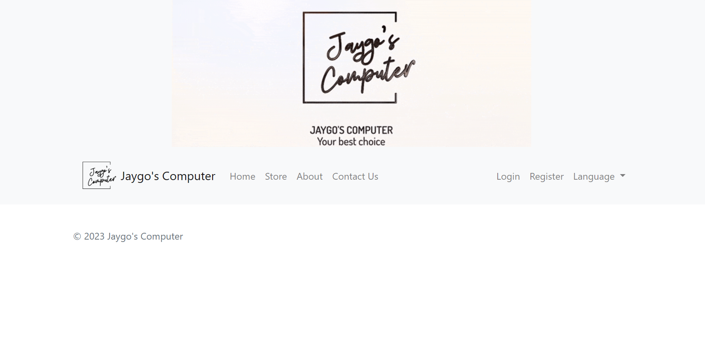

Figure 24 Template page

Home page

The Home Page has two main sections: a carousel displaying the latest products and a grid showcasing popular products. Both sections are dynamically populated based on the data passed to the template, providing a dynamic and ever-changing user experience.

The Latest Products Carousel is a dynamic slideshow that cycles through the latest products added to the website. Each slide contains an image of the product, the product's name, and its price. The product image is a clickable link that navigates to a detailed view of that product. Navigation controls allow the user to manually cycle through the products, and active indicators provide a visual cue of the current position within the slideshow. If no latest products are available, a message is displayed to the user indicating this.

The Popular Products section displays a selection of popular products in a responsive grid layout. Each product is displayed within a card, a common design element used for presenting bite-sized content. Each card contains an image of the product, the product's name, and its price. Like in the carousel, the product image is a clickable link that leads to a detailed view of the product. If there are no popular products available, a message is displayed to the user indicating this.

In essence, this Home Page serves as a showcase for products, enticing users to explore more and potentially make a purchase. It uses a combination of a carousel and a grid layout to present a variety of products in an engaging and user-friendly manner. It also provides easy access to detailed product information, thereby aiding the user's shopping experience.

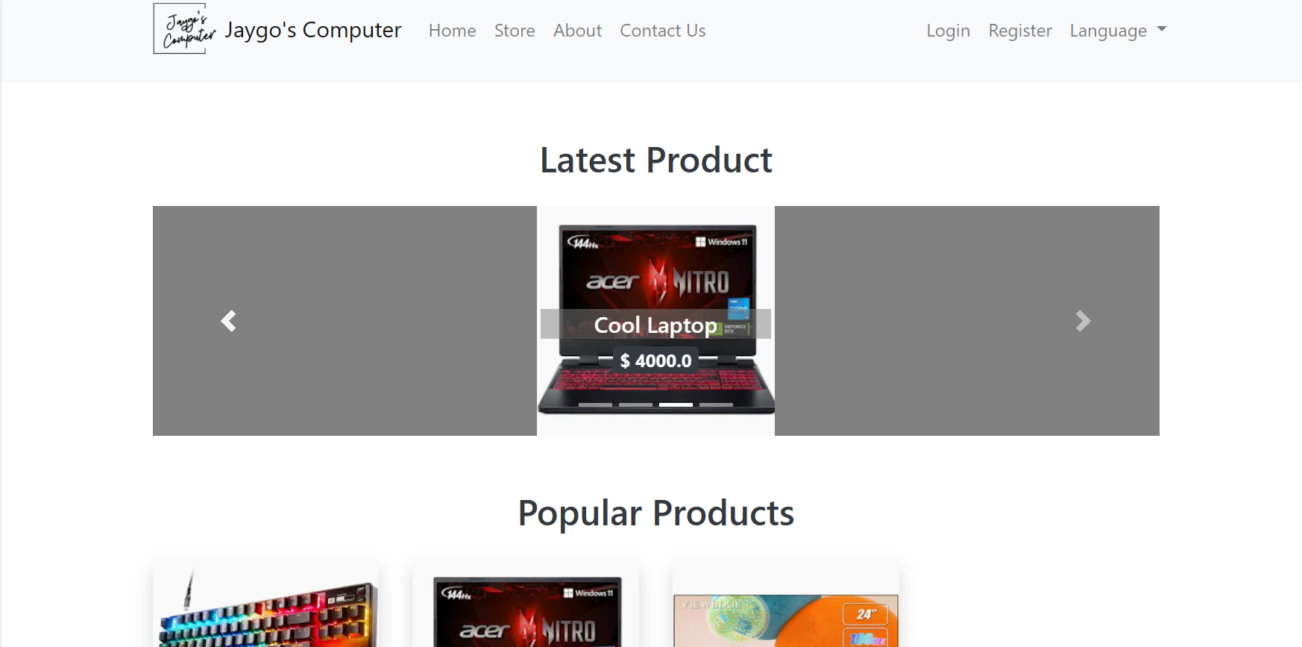

Figure 25 Latest Product section

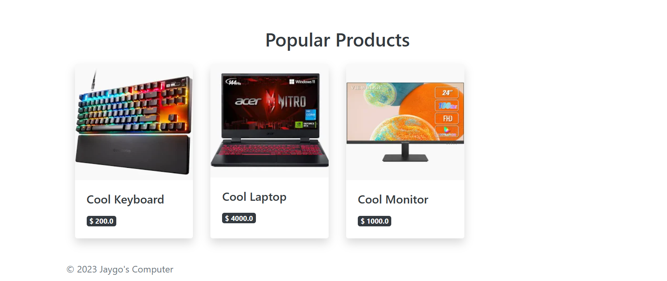

Figure 26 Popular Product section

About us

The About Us page is a crucial part of any website, as it provides users with information about the company, its mission, and its history.

The page begins with a YouTube video, presumably about the company or its products. The video is embedded in the page using the `<iframe>` HTML element, and its settings allow for various features like autoplay, clipboard-write, encrypted-media, gyroscope, picture-in-picture, and web-share. The "allowfullscreen" attribute enables the video to be viewed in full screen.

Below the video, the company shares its story in a series of paragraphs. The first paragraph introduces the company and its dedication to providing the best computers with a focus on quality, reliability, and customer service. The second paragraph tells the story of the company's founding by Jaygo in 2023 and how his passion for cutting-edge computing technology led him to start his own business.

The narrative continues, highlighting the company's growth to serve customers worldwide and expressing excitement at being able to share their passion through their website. The final paragraphs extend an invitation for users to contact the company with any questions or comments and sign off with a personal note from Jaygo, the founder.

In summary, this "About Us" page provides a comprehensive introduction to "Jaygo's Computer", sharing its mission, history, and inviting users to engage with the company.

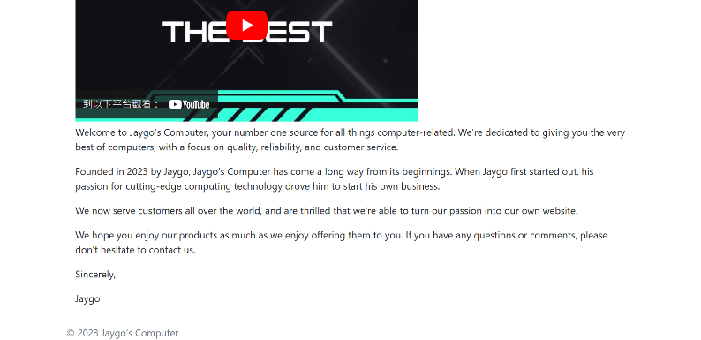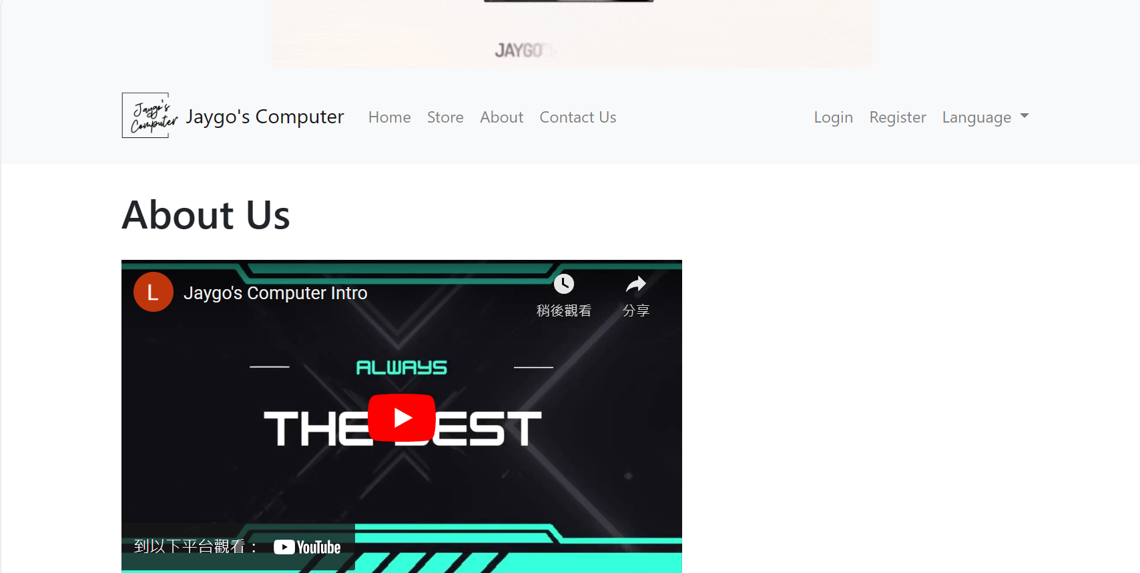

Figure 28

Figure 27

Store

The "Store" page is a critical component of any e-commerce website. It serves as the main interface for customers to browse, search for, and sort products, and it is usually the first page that customers interact with when they visit an e-commerce site.

At the top of the page, there's a search bar that allows customers to enter keywords and find products that match their search criteria. This feature enhances the user experience by making it easy for customers to find specific items they're interested in.

Near the search bar, there's also a dropdown menu for sorting options. This feature enables customers to organize the product list according to different criteria, such as by rating. This is particularly useful when there are many products, as it helps customers to navigate through the product list more efficiently.

On the left side of the page, there's a list of product categories. This feature allows customers to narrow down their browsing to a certain type of product. Each category acts as a filter when a category is clicked, the product list updates to display only products from that category.

The main section of the page is dedicated to displaying the products. Each product is displayed on a card that shows an image of the product, the product's name, its price, and a button for more details. The product image gives customers a visual impression of the product, the name and price provide essential information, and the button allows customers to access a detailed view of the product.

In the detailed view, customers can find more information about the product, such as its full description, specifications, customer reviews, and more. This is where customers can really learn about the product and decide whether it meets their needs.

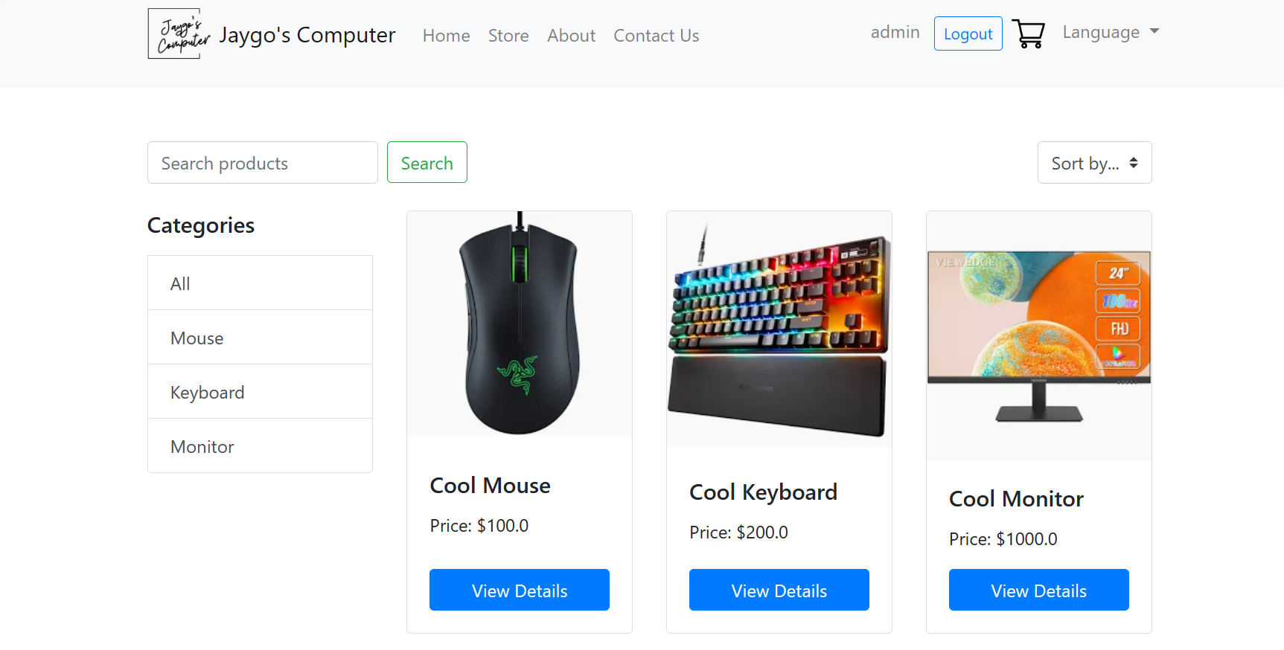

Figure 29 Store page

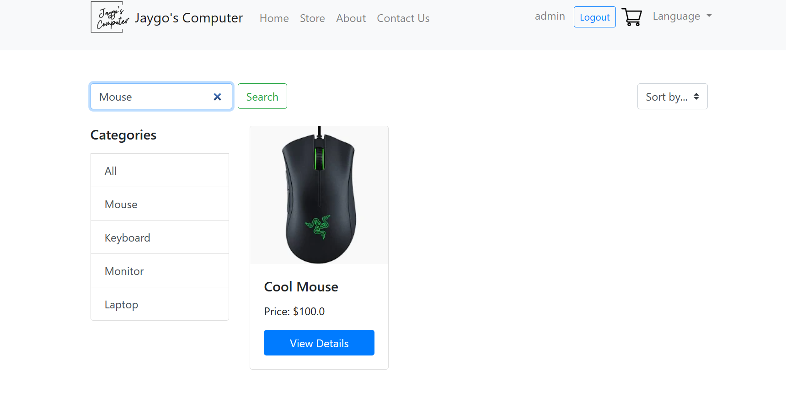

Figure 30 Searching

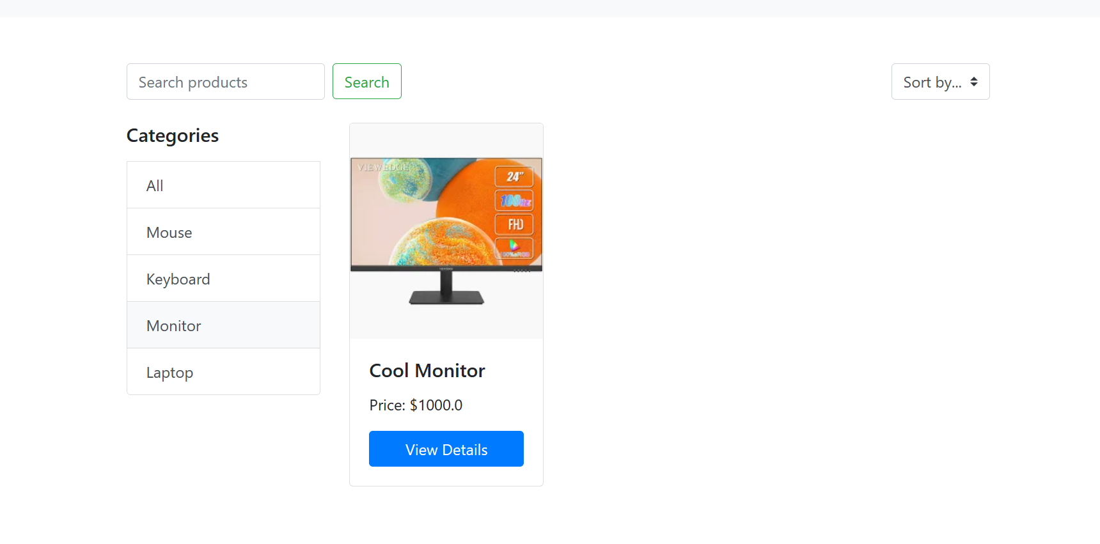

Figure 31 Filtering

Contact Us

The provided code is a template for a 'Contact Us' page on a website, a vital communication channel that allows site visitors to send messages, inquiries, or feedback to the site's administrators. This template is crafted using Jinja, a popular templating language in Python, and extends a base HTML template ('base.html') that typically includes common elements across all webpages such as the header and footer.

This 'Contact Us' page is structured in a way that makes it responsive and visually appealing. It employs Bootstrap classes, which offer a versatile grid system and pre-designed components to make the page look professional and function seamlessly on various screen sizes.

The central feature of the 'Contact Us' page is a contact form. This form is carefully designed to gather important information from the user, structured as follows:

1. Name: This is a text input field where users are expected to enter their name. The 'required' attribute ensures that the form cannot be submitted without this information, emphasizing its importance as a basic identifier.
2. Email: This is an email input field where users are expected to provide their email address. This field is also required. The email address is crucial as it will likely be the primary method for site administrators to respond to the user's inquiry or feedback.
3. Subject: This text input field is for users to enter the subject of their message. This helps provide context for the message and can assist administrators in prioritizing and categorizing incoming messages.
4. Message: This is a text area intended for users to write the body of their message. This could include specific inquiries, feedback, or any other information the user wishes to convey. The 'required' attribute ensures that users cannot submit an empty message.

Upon filling out all the fields, the user can submit the form by clicking the 'Submit' button. In the provided code, clicking 'Submit' will lead the user to a '/contact-success' page, which could potentially display a message confirming successful form submission. However, it's important to note that the form action is not defined in the provided code — in a fully functional form, the form data would be sent to a server-side script (not shown here) to process the data.

The 'Contact Us' page serves as a fundamental communication tool between the website and its visitors. Whether it's for handling inquiries, receiving feedback, or assisting with problems, this page aids in fostering open communication and improving overall user experience. The design and functionality of this 'Contact Us' page make it easy for users to reach out and for administrators to manage and respond to these messages in a structured manner.

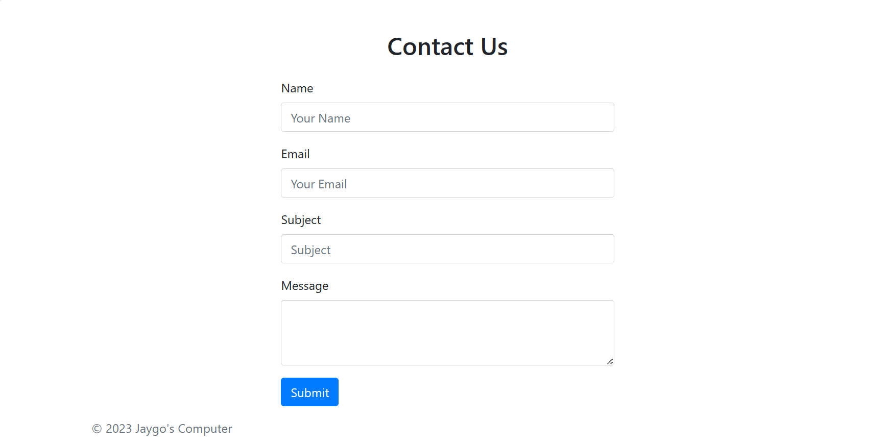

Figure 32

Payment

Payment page is written in Jinja which is a templating language for Python. It extends from a 'base.html' template. Typically, this base template includes common elements shared across the site like the header, footer, and potentially some common scripts or styles.

The 'Payment Page' is structured in a responsive design manner, employing Bootstrap classes for the grid system and other styles. The page is essentially divided into four major sections:

1. Order Summary: It presents a table listing details of the products in the user's cart. The table contains columns for the product name, price, and quantity. A Jinja for-loop is used to dynamically populate the data in the table iterating over the 'products' object, which should have been passed from the backend. After the table, the total price of the products is displayed.
2. Customer Information: This part of the form collects basic user details. This includes fields for the user's name and email. Both fields are tagged as 'required', indicating that they need to be filled out for the form to be submitted.
3. Shipping Information: This section is dedicated to collecting the shipping address for the order. Like the previous fields, the 'address' field is also marked as 'required'.
4. Payment Details: This section is where users will provide their payment details. It includes fields for the name on the card, card number, expiry date, and CVV. It's noteworthy that the input fields are designed with some form of validation using the 'pattern' attribute, ensuring that the input matches the format of a typical card number, expiry date, and CVV.

Once the user has provided all the necessary information, they can make the payment by clicking the 'Pay Now' button. This action will redirect the user to a '/success' page, which likely confirms that the payment was successful. The form also includes a 'Back to Cart' button, providing users with the option to return to their shopping cart.

There is a script at the end of the page that uses jQuery to enhance the user experience. Specifically, it automatically adds a '/' after the user enters the month in the card's expiry date field. This small tweak improves usability by making it easier for users to input their card's expiry date correctly.



Figure 33

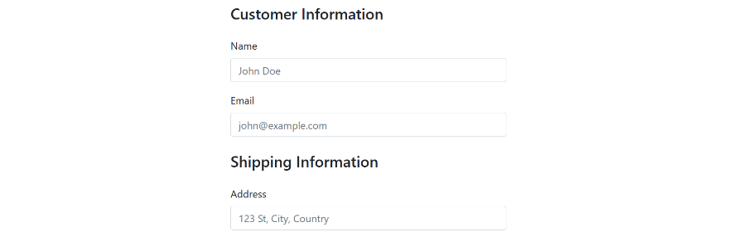

Figure 34

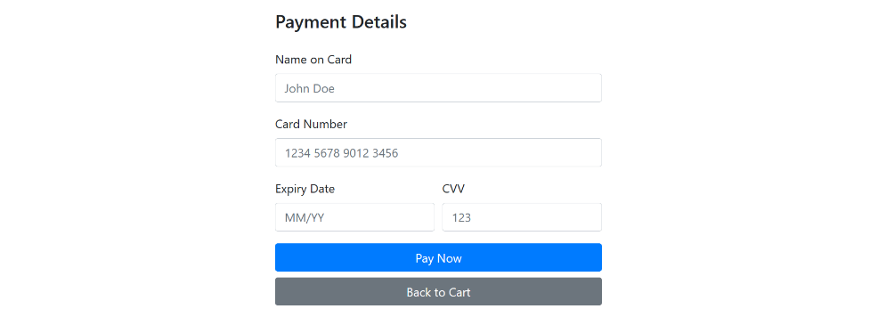

Admin panel

In order to allow admin manage the product much easier, a admin panel page has been created.

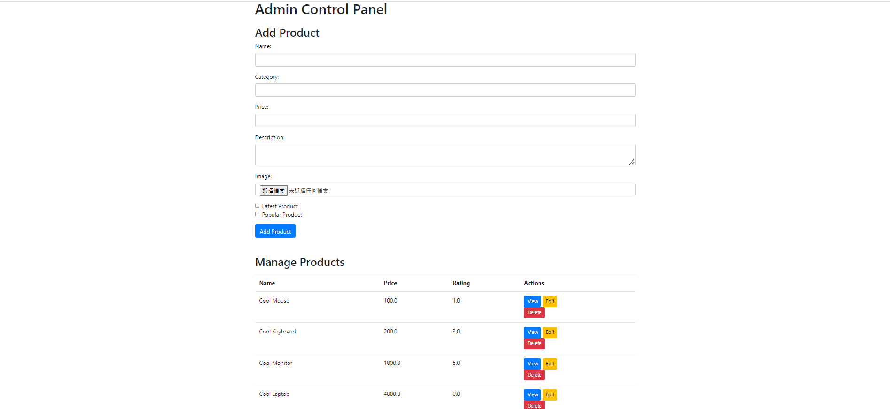

Figure 35

'Admin Panel' webpage, designed to facilitate key administrative functions, namely the addition of new products and the management of existing ones. This template is written using Jinja, a widely-used templating language in Python, and is extended from a base HTML template.

The 'Admin Panel' page is divided into two main sections: 'Add Product' and 'Manage Products', each designed to perform specific administrative tasks.

The 'Add Product' section provides a form that enables the addition of new products to the site's database. This form is designed to collect several critical pieces of information about a product:

1. Name: The product's name, inputted in a text field.
2. Category: The category to which the product belongs, inputted in a text field.
3. Price: The product's price, inputted in a numerical field.
4. Description: A detailed description of the product, inputted in a text area.
5. Image: An image of the product, uploaded via a file input field.
6. Latest Product: A checkbox that, when ticked, flags the product as a 'Latest Product'.
7. Popular Product: Another checkbox that, when ticked, flags the product as a 'Popular Product'.

Once the admin fills out this form and clicks the 'Add Product' button, a POST request is sent to the server, carrying the form data. The server-side application can then use this data to create a new product entry in the database.

The 'Manage Products' section of the page provides the admin with an overview of all existing products on the site. Here, the products are displayed in a table format, showing each product's name, price, and rating.

For each product in the table, three action buttons are provided:

1. View: This button, when clicked, takes the admin to a detailed view of the product.
2. Edit: Clicking this button takes the admin to a page where they can edit the product's details.
3. Delete: This button triggers the deletion of a product. Before the deletion is executed, a confirmation prompt appears to confirm that the admin indeed wants to delete the product.

Login

The 'Login' page is a vital part of any website that requires user interaction and personalization. It's the entrance to the user's personal account, where they can access and manage their information, preferences, and other account-specific features that aren't available to anonymous visitors.

The 'Login' page on this site is designed with a clear and intuitive layout to ensure a smooth and efficient user experience. The primary element on the page is a form, which is enclosed within a visually distinct card component. This design choice helps users immediately identify where they need to input their information, reducing any potential confusion.

The form on the 'Login' page asks users to provide two key pieces of information: their username or email, and their password. These are standard elements for login forms, as they allow the system to securely verify the identity of the user.

One of the important features of this 'Login' page is its ability to handle and display validation errors. If a user provides incorrect or invalid data, such as a username that doesn't exist or a wrong password, the page can show an error message directly under the respective input field. This feature provides immediate feedback to the user about what they need to correct, which is an essential aspect of creating a user-friendly form.

For visitors who don't yet have an account, the 'Login' page provides a helpful feature: a direct link to the registration page. This link is displayed below the login form, ensuring it's easily accessible for those who need it. It's a thoughtful design choice that anticipates the needs of new visitors, making the site more welcoming and easy to use.

In addition to these individual elements and features, the overall design and layout of the 'Login' page contribute to its functionality. The use of clear labels, appropriate spacing, and a straightforward flow from one element to the next all help make the login process as easy and painless as possible for the user.

In summary, the 'Login' page serves as a gateway to the user's personal account and a guide for navigating the website. It's designed with the user's needs in mind, providing clear instructions, immediate feedback, and helpful links to ensure a smooth and pleasant user experience.

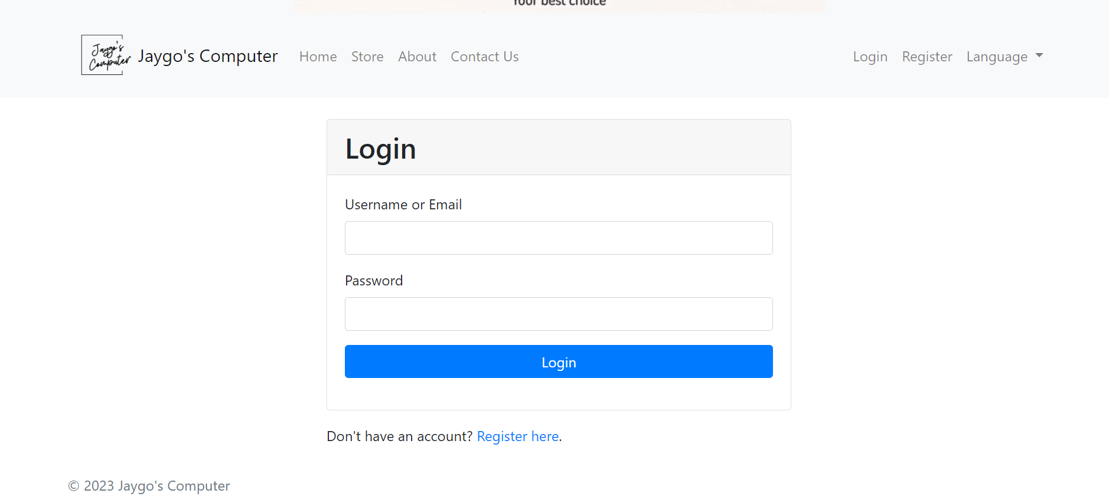

Figure 36

Register

The provided code represents a User Registration Page, a crucial element in the user management system of a web application. As the entry point for users to create their own accounts, the role of this page extends beyond just data collection—it sets the tone for the user experience and can strongly influence users' initial perceptions of the application.

The Registration Page primarily revolves around a form that collects key pieces of user information—username, email, password, and password confirmation. The username and email allow the application to uniquely identify users, establishing a personal space for them within the application, storing their preferences, and potentially providing personalized content. The password and its confirmation field ensure that the user has a secure way to access this personal space later, and the matching of the two fields helps prevent the common mistake of a typo in a password that the user can't see while typing.

One of the notable features of this page is its robust error handling. For each of the input fields in the form, the template checks for errors. If any exist, they're displayed to the user. This feedback can guide the user towards providing the required information in the correct format. For instance, if the error handling logic detects that the provided email does not match the expected pattern for email addresses, it could inform the user that they need to provide a valid email address.

Furthermore, the template includes a link to the login page. This is an important feature because users may navigate to the registration page even if they already have an account. By providing a link to the login page, the application improves its navigation and usability, ensuring that users can quickly find their way to the correct location.

In addition, the layout of the Registration Page is likely to follow the design and layout of the "base.html" template. This ensures a consistent look and feel across the web application, which can contribute to a more comfortable and intuitive user experience.

In conclusion, the User Registration Page is a sophisticated tool that plays a key role in user management. It welcomes new users to the application, guides them through the registration process with helpful feedback, and helps existing users navigate to the correct place. By doing so, it sets a foundation for a positive, user-friendly experience in the application.

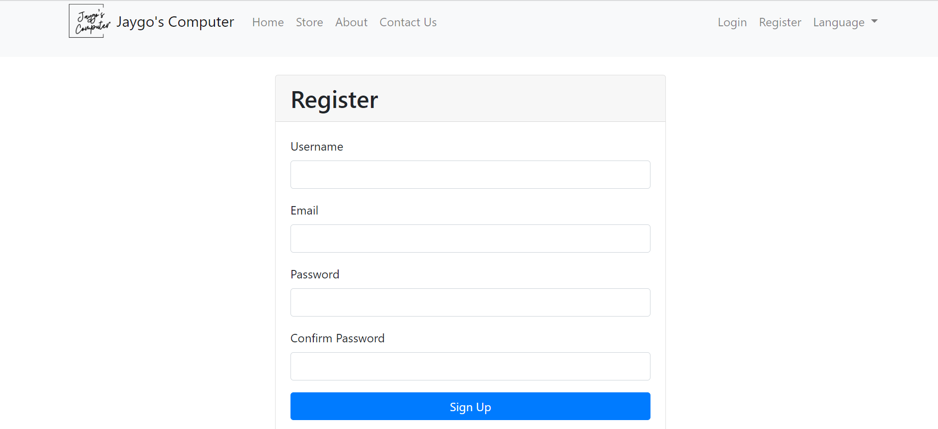

Figure 37

Product page

The page contains a CSS section that defines the styles for displaying star ratings. The stars are grey by default and turn gold when checked. There's also CSS for organizing the stars inline and hiding radio buttons, which are used to capture the rating from users.

The main content of the page is wrapped in a container. It's divided into two sections. On the left, there's a product image. On the right, there's information about the product, such as its name, description, price, and rating. There are also messages indicating whether the product is new or popular. There's an "Add to Cart" button for purchasing the product.

Following the product information, there's a comment section. Each comment is displayed within a card that shows the username, the comment text, and the user's rating for the product. The star rating is displayed visually using gold and grey stars. If the current user is the author of a comment, they'll see "Edit" and "Delete" buttons next to their comment.

If the current user is authenticated and hasn't already commented or rated, they can leave a comment and give a rating. This is done through a form that contains a text area for the comment and a group of radio buttons for the rating. The radio buttons are visually represented as stars and users can click on a star to select a rating. The overall rating will be calculated automatically.

There's also JavaScript code that enhances the user experience when giving a rating. It changes the color of the stars when a user hovers over them and selects the stars when clicked. It also ensures that only one rating can be selected at a time.

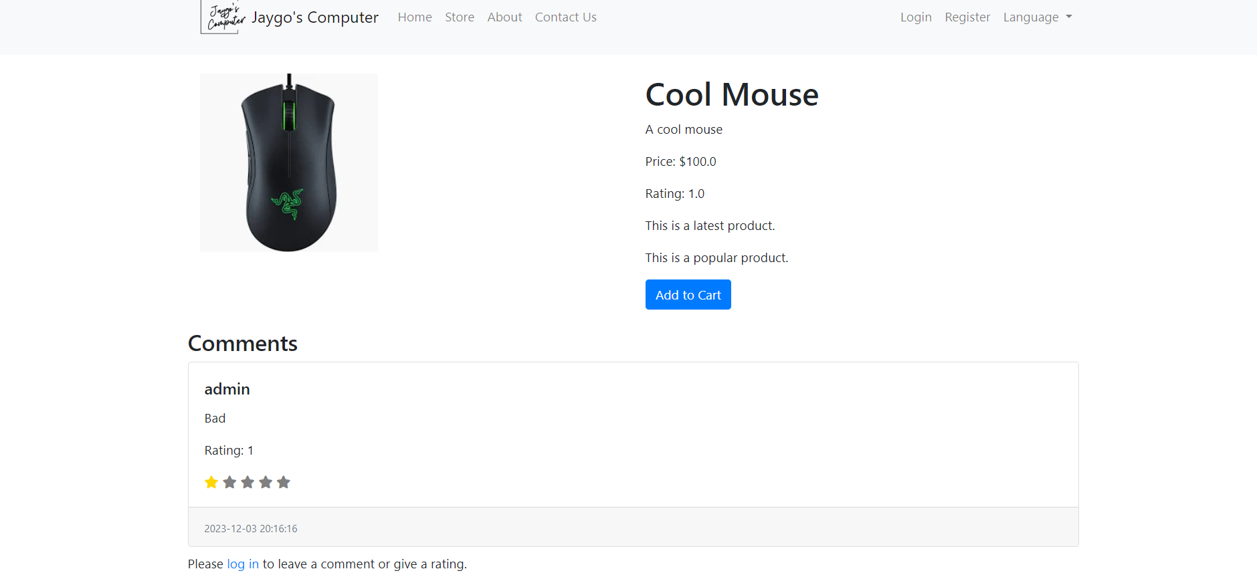

Figure 38

Shopping cart

The page displays the contents of the user's shopping cart in a structured and organized manner.

The main part of the page is dominated by a table that lists all the items the user has added to their shopping cart. Each item is presented in a separate row, with detailed information about each product.

For each product, the name is displayed, which likely also serves as a link to the product's individual page for users who might want to review the product details again. The price of each product is listed, as well as the quantity that the user has chosen to purchase. Users have the option to adjust the quantity directly from this page, offering a user-friendly way of updating their order without having to navigate away from the page.

Additionally, the total cost for each product (calculated by multiplying the price per item with the quantity) is shown, giving users an overview of how much they're spending on each item. For users who change their mind about a product, there's an easy option to remove the item entirely from their cart.

After all the individual products have been listed and their costs calculated, the page provides a grand total cost for all the items in the cart. This total cost is prominently displayed, helping users understand what their overall expenditure will be.

Finally, a button at the bottom of the page allows users to proceed to the next step of the purchasing process. This likely takes them to a secure payment page where they can complete their purchase, providing a smooth, end-to-end shopping experience.

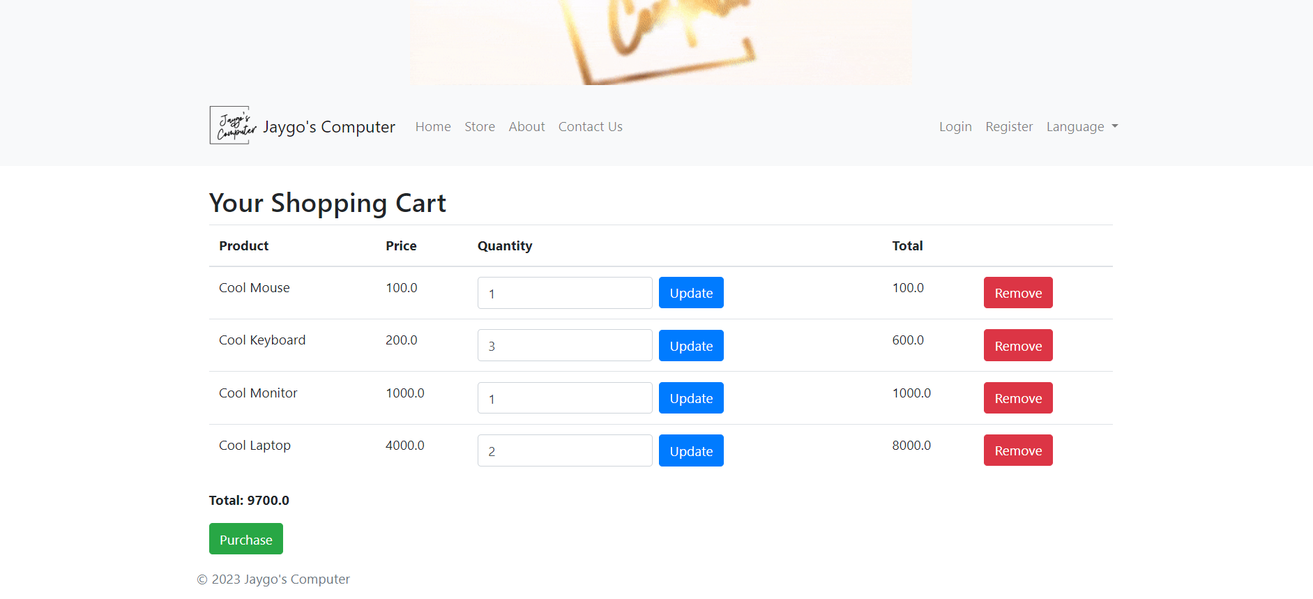

Figure 39

**Development Tools**

Programming languages

Introduction To Frontend

In this project, the web pages are written in html code, with jinja template language. The responsive functions are written in Javascript. For styling, an external CSS framework called bootstrap is used.

HTML with Jinja Template Language

*HTML*

HTML, which stands for HyperText Markup Language, is the standard markup language used in the creation of web pages. It provides the structure of web content, organizing elements such as headings, paragraphs, links, and images. Unlike a programming language, HTML is a markup language that annotates text to distinguish different parts of a document for rendering by web browsers.

An HTML file is a simple text file saved with an `.html` extension, interpreted by web browsers to render the webpage to users. The elements in HTML are represented by tags, enclosed in angle brackets (`<>`). These tags, such as `<head>`, `<body>`, `<p>`, and `<div>` among others, guide how the web content should be structured and interpreted.

HTML is managed by the World Wide Web Consortium (W3C) and the Web Hypertext Application Technology Working Group (WHATWG). As of the knowledge cutoff in September 2021, the present version is HTML5. HTML5 introduces support for multimedia elements and is designed to be more readable for both humans and machines.

*Jinja Template Language*

Jinja is a high-performance templating language for Python, often used to generate dynamic web content. With Jinja, it's possible to include variables, loops, and other logic within HTML files. This enables the creation of more complex and interactive websites that can adapt based on user input or other events.

While Jinja is frequently used with the Flask web framework, it can be adapted for other Python projects as well. Its syntax is similar to Python, making it intuitive for developers familiar with the Python language.

One of the primary advantages of Jinja is template inheritance. This enables developers to create a base "skeleton" template with common site elements and define blocks that can be overridden by child templates. This promotes reusability and helps maintain the DRY (Don't Repeat Yourself) principle in your code.

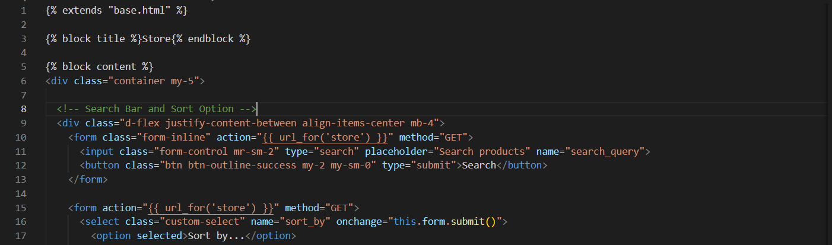

Figure 40 Example of html with Jinja template language

CSS

CSS, or Cascading Style Sheets, is a style sheet language used for describing the look and formatting of a document written in HTML. It is a cornerstone technology of the World Wide Web, alongside HTML and JavaScript. CSS is designed to enable the separation of presentation and content, including layout, colors, and fonts.

Unlike HTML that provides structure to web content, CSS deals with the aesthetic aspect of web pages. It determines how the HTML elements should be displayed on screen, paper, or in other media. CSS saves a lot of work as it can control the layout of multiple web pages all at once. This separation of HTML from CSS makes it easier for designers to create attractive web pages and users to customize the appearance of web pages to their liking.

CSS rulesets consist of selectors and declarations. Selectors target the HTML elements that the style will be applied to, and the declarations specify what the style actually is. These declarations are grouped into blocks, which are enclosed by curly braces `{}`. Each declaration includes a CSS property name and a value, separated by a colon `:`.

CSS files are typically separate from HTML files and are linked within the HTML’s head section using the `<link>` tag. They can also be embedded directly into HTML documents or inline with specific HTML elements, although these methods are less commonly used due to their limitations in maintainability and reusability.

CSS is maintained by the World Wide Web Consortium (W3C). As of my knowledge cutoff in September 2021, the current version is CSS3, which introduces features like rounded corners, shadows, gradients, transitions, or animations, and new layout concepts like CSS Grid or Flexbox.

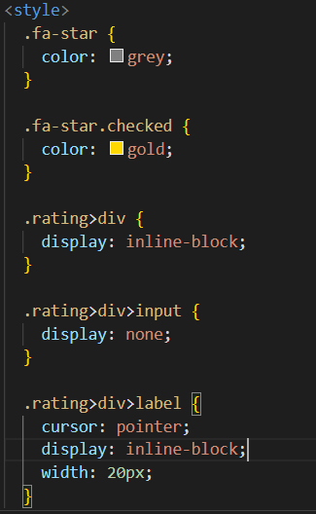

Figure 41 Example of CSS

Bootstrap

Bootstrap is a free and open-source CSS framework directed at responsive, mobile-first front-end web development. It comprises CSSand (optionally) JavaScript-based design templates for typography, forms, buttons, navigation, modals, and other interface components. Bootstrap can help make website development faster and easier.

Created by Twitter developers and initially released in 2011, Bootstrap has gained popularity as a tool for developing responsive and mobile-first websites. Responsive web design is a design approach where your website's design elements will automatically adjust to the visitors’ device screen size and viewing environment. This ensures that websites provide a smooth user experience across different devices, such as desktops, tablets, or smartphones.

Bootstrap provides pre-styled components, CSS styles and JavaScript plugins which can be easily incorporated in a web design. It uses a grid system for layout, which greatly simplifies creating complex layouts. With classes for setting widths, offsets, alignment and more, Bootstrap's grid system allows for up to 12 columns across a page.

A major advantage of using Bootstrap is that it saves the developer from writing a lot of CSS code, as Bootstrap comes with built-in CSS styles. Moreover, it also ensures consistency regardless of who's working on the project, and it can be customized if you wish to tweak the built-in styles.

For examples:



Figure 42

Without any extra coding, the button will automatically become this with bootstrap installed:

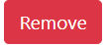

Figure 43

Javascript

JavaScript is a high-level, interpreted scripting language that is one of the core technologies of the World Wide Web, alongside HTML and CSS. While HTML provides structure and CSS handles layout and styling, JavaScript enables interactivity and dynamic content in web pages.

First appearing in 1995, JavaScript was introduced by Netscape Communications to add more functionality to web pages than just static HTML and CSS. Since then, it has become an essential language for web development, with all modern web browsers providing built-in JavaScript engines.

JavaScript is a versatile language and is used not only on the client-side (in the browser) to make web pages interactive, but also on the server-side with technologies like Node.js. It can be used to create a range of features, such as form validation, user interaction (like responding to clicks or key presses), animation, and communication with servers to load new content without reloading the entire page (known as AJAX).

JavaScript's syntax is influenced by the programming language C, but it is more forgiving and flexible. It's a prototype-based, multi-paradigm language that supports imperative, object-oriented, and declarative programming styles.

One of the key features of JavaScript is the Document Object Model (DOM). The DOM is a programming interface that lets JavaScript interact with HTML and CSS. Scripts can use the DOM to create, read, update, and delete elements on a web page, allowing for dynamic content changes.

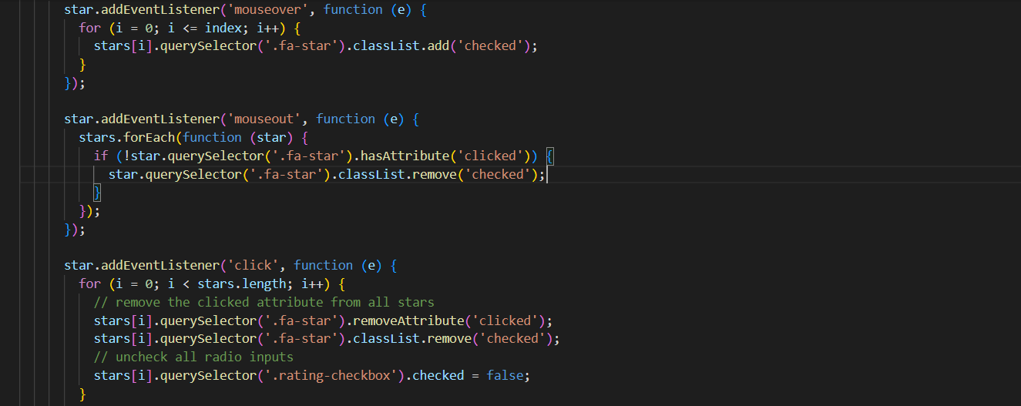

Figure 44 Example of Javascript code

Introduction to Backend

Backend is usually known as server-side app. With backend applications, many functions can be done, such as login, register, adding products to cart etc.

Python

Python is a high-level, interpreted programming language known for its readability and simplicity. It was created by Guido van Rossum and first released in 1991. Python's design philosophy emphasizes code readability with its use of significant indentation and clear, expressive syntax. This makes Python relatively easy to learn and read, which has contributed to its popularity for beginners and experts alike.

Python is a general-purpose language, which means it can be used for a wide range of applications. It's commonly used for web development, data analysis, machine learning, artificial intelligence, automation, and more. It's also widely used in scientific computing, education, and embedded applications.

Python supports multiple programming paradigms, including procedural, object-oriented, and functional programming. It features a dynamic type system and automatic memory management, allowing for flexibility and ease of use.

Python's standard library is extensive and includes modules for handling files, internet protocols, string operations, and operating system interfaces, among others. This, combined with Python's robust ecosystem of third-party packages (which can be installed using pip, Python's package manager), allows for increased productivity and capability.

Python interpreters are available for many operating systems, and a global community of programmers and software developers supports Python. The language is currently managed by the Python Software Foundation.

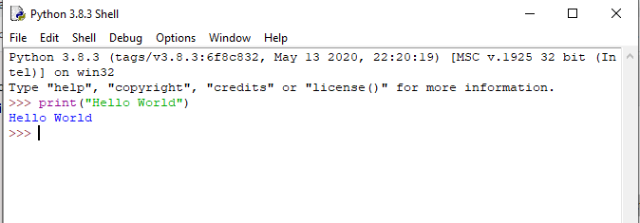

Figure 45 Example of Python

Flask

Flask is a lightweight and flexible web development framework for Python. It's designed as a microframework, which means it includes only the bare minimum of functionality by default, but can be easily extended with various extensions. It was developed by Armin Ronacher and released in 2010 as a "April Fool's" joke, but it quickly gained popularity due to its simplicity and flexibility.

Flask is suitable for both small and large applications. It does not impose a specific structure or pattern for creating applications, like some other frameworks do. This means that developers have a lot of freedom, but also a lot of responsibility to structure their applications in a maintainable way.

The core of Flask is very simple: it's essentially a routing system (matching URLs to Python functions) plus some utilities for handling requests and responses. This simplicity makes Flask very easy to understand and get started with, even for developers who are new to web development.

Flask applications can handle multiple types of requests, including GET and POST requests. It can also handle cookies and sessions, which are essential for creating interactive, stateful web applications.

Flask uses the Jinja template engine by default, which allows for dynamic generation of HTML pages. This means that you can use Python code in your HTML files to generate pages that are customized to each user, or each request.

Flask is typically used with a WSGI server, such as Gunicorn or uWSGI, which serves the Flask application to the web. It can also be used with any web server that supports CGI, FastCGI, or a similar interface.

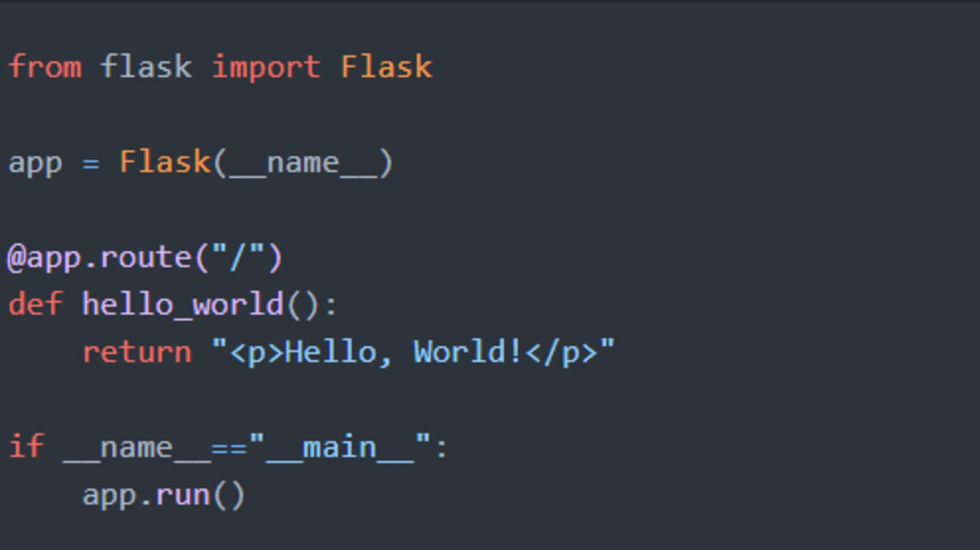

Figure 46 Example of Flask app

Modules

In Python, a module is a file containing Python definitions and statements. The file name is the module name with the suffix `.py` added. Within a module, the module’s name (as a string) is available as the value of the global variable `__name__`.

Modules in Python serve to organize code, making it easier to understand and use. They can define functions, classes, and variables that can then be utilized in other Python programs when the module is imported. This allows for code to be reused across multiple programs without the need to copy and paste it.

To use a module in a Python program it first has to be imported. A module can be imported using the `import` statement. For example, to import a module named `example`, you would write `import example` at the top of your script. You can then access functions or variables defined in the module with the dot operator, like `example.function()`.

There are several ways to import modules. If you only need a specific function from a module, you can import only that using the `from` keyword, like `from example import function`. If you want to import all functions and variables from a module, you can use `from example import *`. Be aware that this method can lead to confusion if different modules have functions with the same name.

Python comes with a standard library, which is a vast collection of modules that provide functionalities for many common tasks, such as file I/O, system calls, sockets, and even interfaces for email and web protocols. Some examples of standard library modules include `os`, `sys`, `math`, `json`, `datetime`, and `random`.

In addition to the standard library, there are numerous third-party modules available that provide additional functionality. These can usually be installed via Python's package manager, pip. Examples of popular third-party Python libraries include `numpy` for numerical operations, `requests` for making HTTP requests, `pandas` for data manipulation, `matplotlib` for plotting, and `tensorflow` for machine learning.

In conclusion, modules in Python are an essential part of the language that allow for code organization and reuse. They range from the standard library modules included with Python to third-party modules that can be installed as needed.

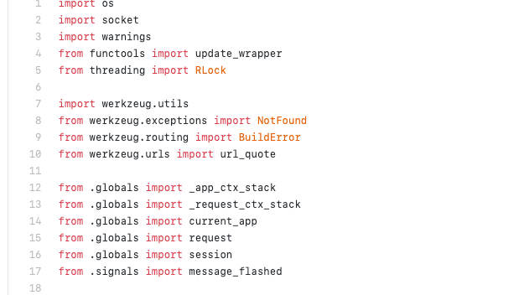

Figure 47 Example of importing modules in python

**Modules used in the project**

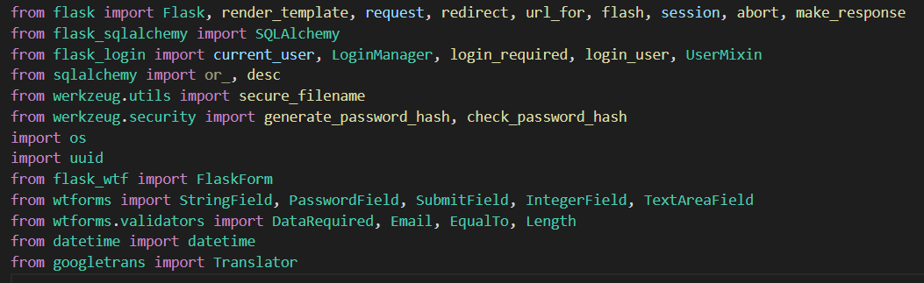

Figure 48

1. Flask: This is the main Flask class that represents an application.
2. render_template: This function is used in Flask to generate output from a template file based on the Jinja2

engine that is found in the application's templates folder.

1. request: This is a global object in Flask that holds the current request data.
2. redirect: This function is used to redirect the user to a different endpoint.
3. url_for: This function is used to generate URLs for a given endpoint.
4. flash: This function is used to send a message that can be rendered in templates.
5. session: This is a global object in Flask that allows you to store information specific to a user from one request to the next.
6. abort: This function can be used to abort a request and return an HTTP error code.
7. make_response: This function wraps the return value from a route function and turns it into an instance of `response_class`.
8. SQLAlchemy: SQLAlchemy is a SQL toolkit and Object-Relational Mapping (ORM) system for Python. `flask_sqlalchemy` is a Flask extension that simplifies the use of SQLAlchemy with Flask by providing useful defaults and extra helpers.
9. current_user, LoginManager, login_required, login_user, UserMixin: These are components of `flask_login`, a package that manages user sessions for Flask.
10. or_, desc: These are SQLAlchemy functions for building SQL expressions. `or_` corresponds to the SQL OR operator, and `desc` specifies descending order for a query.
11. secure_filename: This function from `werkzeug.utils` ensures a filename is secure, i.e., it doesn't contain special characters or parts that might navigate to different directories.
12. generate_password_hash, check_password_hash: These functions from `werkzeug.security` are used to hash passwords securely, and then to check a password against a given hash.
13. os: This is a built-in Python module for interacting with the operating system. It allows you to use functionality of the underlying operating system, e.g., reading or writing to the filesystem, starting or killing processes.
14. uuid: This is a built-in Python module for generating universally unique identifiers.
15. FlaskForm: This class in `flask_wtf` represents a form.
16. StringField, PasswordField, SubmitField, IntegerField, TextAreaField: These classes from `wtforms` represent different types of fields in a form.
17. DataRequired, Email, EqualTo, Length: These classes from `wtforms.validators` are various validators that can be applied to a form field.
18. datetime: This is a built-in Python module for working with dates and times.
19. Translator: This class from `googletrans` represents a client to the Google Translate API.

Implementation

Responsive Layouts

Bootstrap responsive features

Bootstrap is a popular HTML, CSS, and JavaScript framework for developing responsive, mobile-first websites. It provides several features that make creating responsive designs easier:

1. Grid System: Bootstrap's grid system uses rows, columns, and containers to layout and align content. It's built with flexbox and allows up to 12 columns across the page. The grid system is responsive, meaning it automatically adjusts according to the screen size. You can also specify different column sizes, hide/show different elements at different screen sizes, and offset or reorder columns for different screen sizes using Bootstrap's grid classes.
2. Responsive Breakpoints: Bootstrap includes a responsive, mobile-first fluid grid system that scales up to 12 columns as the device or viewport size increases. It includes predefined classes for easy layout options, while providing powerful mixins for generating more semantic layouts.
3. Responsive Images: Bootstrap provides a class `.img-fluid` that makes an image responsive. The image will then scale nicely to the parent element.
4. Responsive Utilities: Bootstrap includes utility classes for showing, hiding, aligning, and spacing content based on screen size.

The advantages of having a responsive layout

Improved User Experience: A responsive design ensures that your website looks good on all devices, providing an optimal viewing and interaction experience—easy reading and navigation with minimal resizing, panning, and scrolling—across a wide range of devices (from desktop computer monitors to mobile phones).

Cost-Effective: Maintaining separate sites for your mobile and non-mobile audiences can be expensive. By using responsive design, you can save money by eliminating the cost of paying for a mobile site. You will only need to invest in a single site design to appeal to all visitors and all devices.

SEO Advantages: Google recommends mobile-optimized, responsive designs. Consolidating your content into one site and one URL makes it easier for Google to crawl and index your site, and decreases the chance of on-page SEO errors. For these reasons, a responsive layout can mean better search engine rankings.

Ease of Management: Managing one site and one SEO campaign is far easier than managing two sites and two SEO campaigns. This is a key advantage a responsive website has over a separate mobile site.

Future Proofing: A responsive site can allow for future scalability to new devices sizes and resolutions. As new devices (TVs, watches, glasses, etc.) are being used for web browsing, your responsive site can already be prepared to meet those new devices with a design and experience best suited to whatever screen sizes they have.

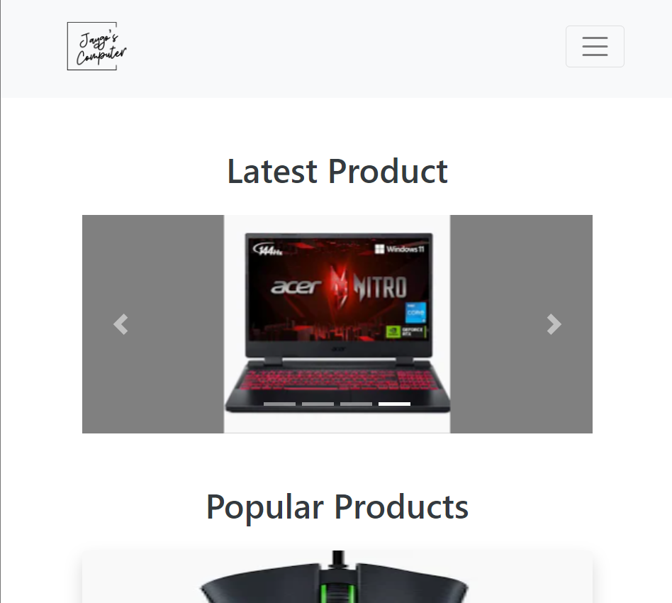

Figure 49 Mobile device

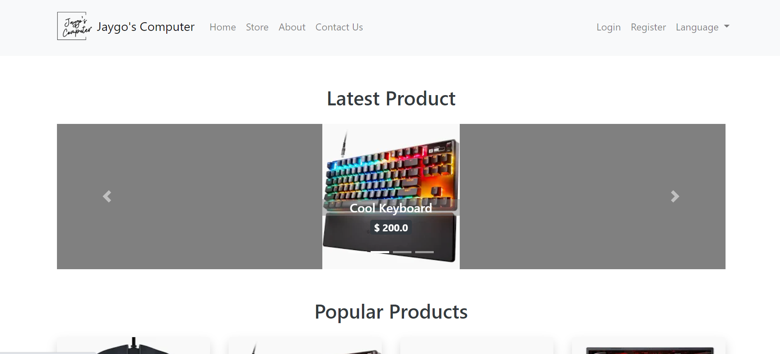

Figure 50 Desktop

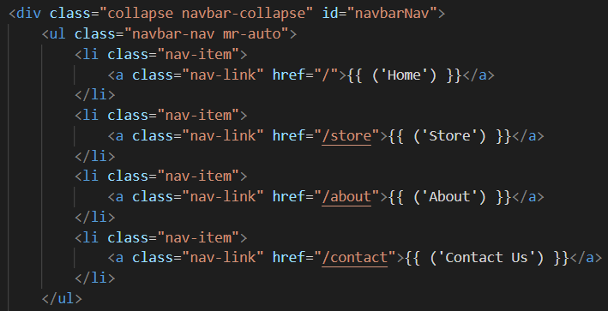

Figure 51 Implementation of code

Templates

Flask uses a template system called Jinja2, which allows you to create dynamic web pages with Python-like syntax.

In Jinja2, a template is a text file that can generate any text-based format. It contains variables that get replaced with values when the template is rendered and tags that control the logic of the template.

In these templates, variables are represented inside double curly braces. When you render the template, you pass in these variables as keyword arguments.

Control flow structures are also included in Jinja2. For instance, you can iterate over each item in a list, or use conditional statements to control what is displayed based on certain conditions.

Another feature of Jinja2 is template inheritance, which allows you to create a base "skeleton" template containing all the common elements of your site. This base template can define blocks that can be overridden by child templates, thus avoiding code duplication.

To protect against Cross-Site Scripting (XSS) attacks, Jinja2 provides an autoescaping feature. This feature automatically escapes special characters in variables that are rendered inside the double curly braces.

In a Flask application, templates are usually stored in a 'templates' directory at the root of the project. You use the function 'render_template()' to render a template. This function takes the filename of the template as its first argument, and any additional arguments are sent to the template as variables.



Figure 52



Figure 53

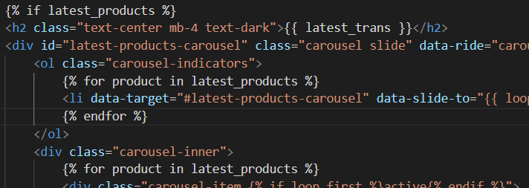

Figure 54



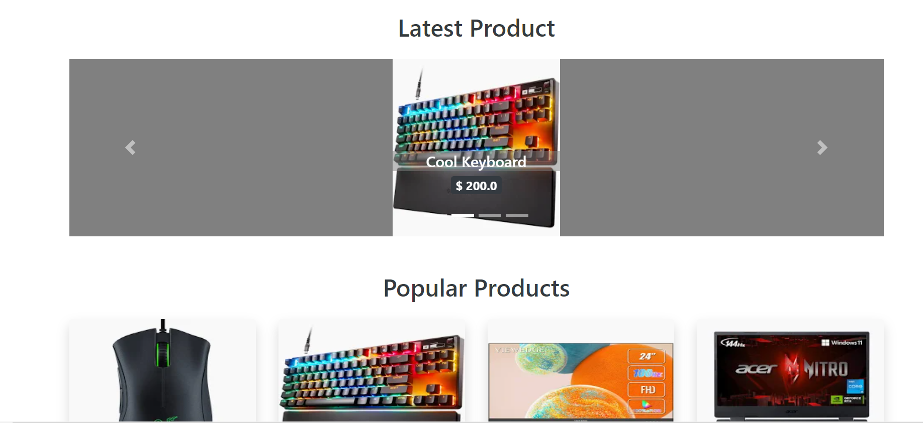

Figure 55

Showing latest and popular products

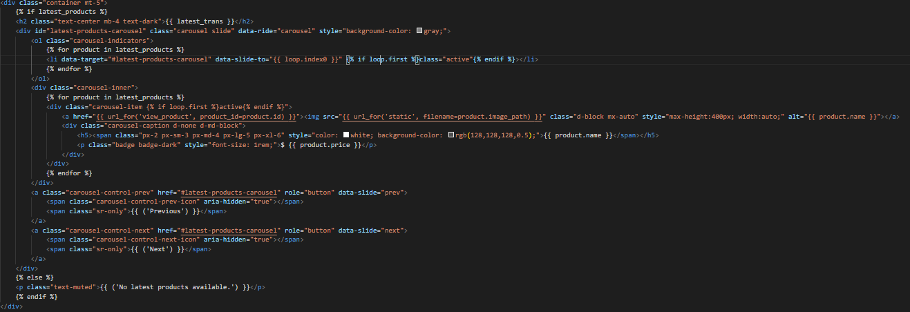

Figure 56

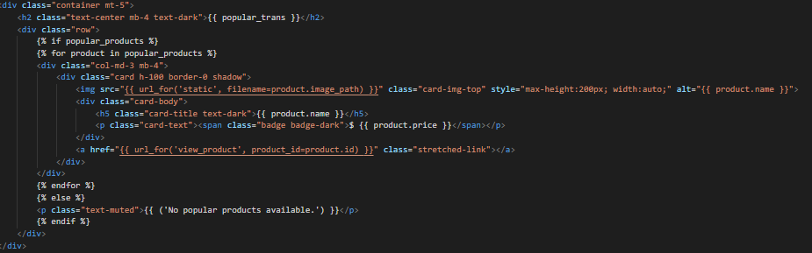

Figure 57

Bootstrap Carousel

The Bootstrap Carousel is a slideshow for cycling through a series of content. It can be used to display images, text, or other content. It's a flexible and responsive component that can be customized to suit a wide range of needs. It can be controlled manually (by clicking on the navigation arrows or indicators) or automatically (by setting a delay time).

Code breakdown:

1. The outer div with class `container mt-5` serves as a container for the carousel. The `mt-5` class adds a top margin to the div for spacing.
2. The `{% if latest_products %}` and `{% endif %}` parts are Jinja2 tags that check if the `latest_products` list is not empty. If it's not empty, the carousel is displayed, otherwise, a message "No latest products available." is shown.
3. The carousel is created inside a div with the classes `carousel` and `slide`, and the `data-ride="carousel"` attribute which enables the sliding feature.
4. Inside the carousel, an ordered list with class `carousel-indicators` is created. Each list item represents an indicator for each product in `latest_products`. The `data-slide-to` attribute is used to specify which slide to go to when the indicator is clicked.
5. The `carousel-inner` div contains the actual content of the carousel. For each product in the `latest_products` list, a `carousel-item` div is created. The `active` class is added to the first product to make it the current slide when the carousel is loaded.
6. Inside each `carousel-item`, an image is displayed with the product's image path. The image is wrapped in a link that leads to the product's page when clicked.
7. Below the image, a `carousel-caption` div is created, which displays the product's name and price. The `d-none` and `d-md-block` classes make the caption hidden on small screens and visible on medium and larger screens.
8. The `carousel-control-prev` and `carousel-control-next` anchors are used to create the previous and next controls. The `data-slide` attribute specifies whether to move to the next (`next`) or previous (`prev`) item when the control is clicked.



Figure 58

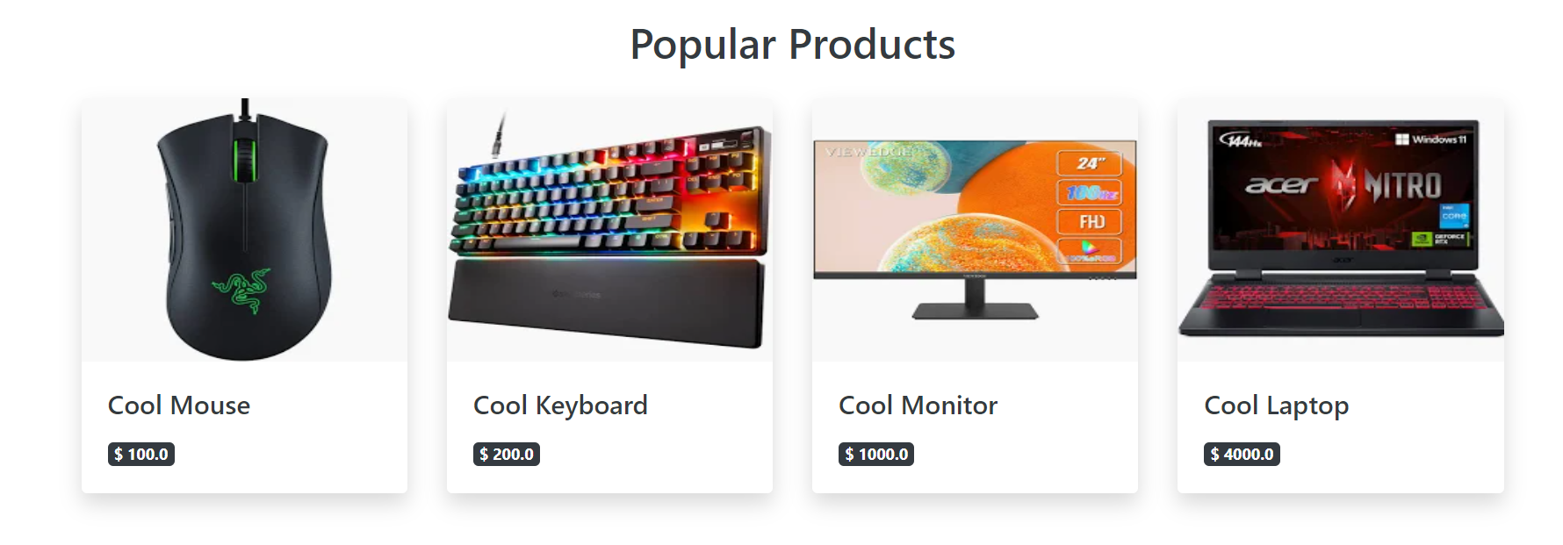

Thumbnail

Thumbnails are reduced-size versions of pictures or videos, used to help in recognizing and organizing them, serving the same role for images as a normal text index does for words. In the age of digital images, visual search engines and image-organizing programs often use thumbnails, as do most modern operating systems or desktop environments, such as Microsoft Windows, macOS, KDE (Linux) and GNOME (Linux).

Advantages of Using Thumbnails

1. Efficient Use of Space: Thumbnails take up less screen space allowing users to view multiple items at once. This is especially useful for image galleries or product catalogs on websites.
2. Faster Load Times: Thumbnails are smaller in size than the original images, which means they load faster. This can improve the user experience on your website, particularly for users with slower internet connections.
3. Improved Navigation: Thumbnails provide a preview of the content (image or video), making it easier for users to find what they're looking for. Users can simply glance at the thumbnail to get an idea of the content without needing to open it.
4. Reduced Bandwidth Usage: Loading a page full of thumbnails uses less data than loading the full-size images. This can be beneficial for users who are on limited data plans or slow connections.
5. Visual Appeal: Thumbnails can make a webpage more visually appealing and organized, which can enhance user engagement. They are an important part of the web design and can contribute to the overall aesthetics of a site.

The product recommendation feature (carousel and grid) also used thumbnails to show the products.



Figure 59

Store page searching, sorting and filtering

This Flask web application template incorporates a store page with searching, sorting, and filtering functionalities.

Searching

The search functionality is implemented inside a form tag. The `input` tag with `type="search"` is where users input a search query. The `name="search_query"` attribute is important as it gives a name to the data input by the user, which the server-side script will use to retrieve the data. When the form is submitted (by clicking the "Search" button), a `GET` request is sent to the `store` route with the search query as a parameter.



Figure 60

Sorting

The sorting functionality is in the second form tag. The `select` tag creates a drop-down menu, where users can select how they want the products to be sorted. In this case, it can be sorted by `rating`. The `onchange="this.form.submit()"` attribute submits the form automatically when the user changes the option selected, sending a `GET` request to the `store` route with the selected sorting option as a parameter.

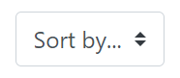

Figure 61

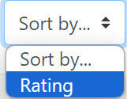

Figure 62

Filtering

The filtering functionality is implemented in the "Filter Categories" section. Here, a list group is created with a list item for each category. When a category is clicked, a `GET` request is sent to the `store` route with the selected category as a parameter. This will display only the products that belong to the selected category.

The "Product Listing" section of the page displays the products. For each product in the `products` list, a card is created displaying the product's image, name, and price, with a link to view more details about the product. This list of products will be affected by the search, sort, and filter parameters.

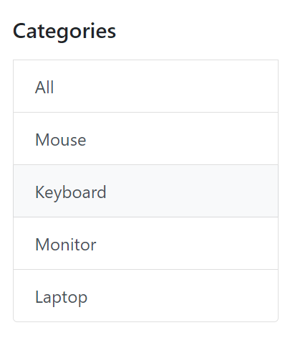

Figure 63

Login and registration

Login

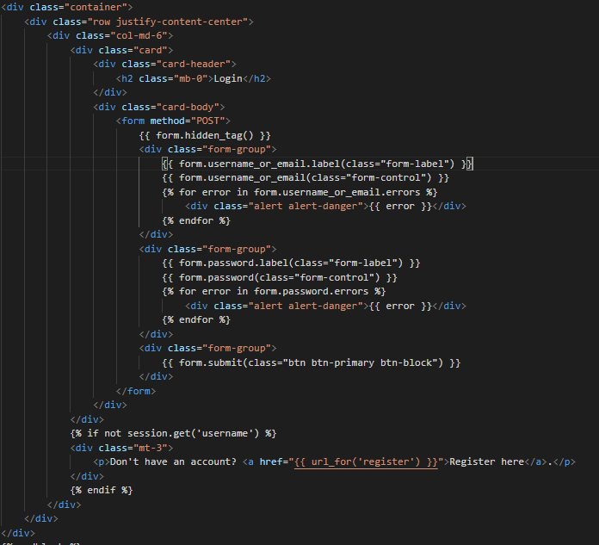

Figure 64

This snippet of code is a login page template for a Flask web application. It allows users to submit their username (or email) and password to authenticate themselves and gain access to restricted areas of the application.

Key components include:

1. A form that sends data as a POST request, a common method for securely transmitting user data.
2. CSRF protection via `{{ form.hidden_tag() }}`, which generates a hidden form field with a validation token.
3. Form fields for the user's username (or email) and password, rendered with HTML classes for styling.
4. Error handling that displays any validation errors related to the username or password fields.
5. A submit button to send the form data to the server.
6. A conditional statement checking if a user is not logged in, and if not, provides a link to the registration page.

Here's a breakdown of the key pieces:

1. The `form.method="POST"` attribute in the form tag indicates that the form data will be sent to the server as a POST request when the form is submitted. POST requests are used to send user-inputted data to the server securely.
2. `{{ form.hidden_tag() }}` is a CSRF (Cross-Site Request Forgery) security feature provided by Flask's WTForms library. It generates a hidden input field containing a token that validates the form submission, preventing CSRF attacks.
3. The `form.username_or_email` and `form.password` are form fields defined in the Flask's WTForms library. They are rendered in the HTML template with additional classes for styling, and their associated labels are also included.
4. `{% for error in form.field_name.errors %}` loops are used to display any validation errors for each field. These might be errors like "This field is required" or "Invalid email address".
5. `{{ form.submit }}` is the submit button for the form. Once clicked, the form data will be sent to the server.
6. The `{% if not session.get('username') %}` block checks if a user is not already logged into a session. If the user isn't logged in, it provides a link to the registration page, indicating that the user can register if they don't have an account.

This is the front-end part of the login process, and the actual authentication would be handled server-side. The users’ data are stored using a database system, which will be introduced later.

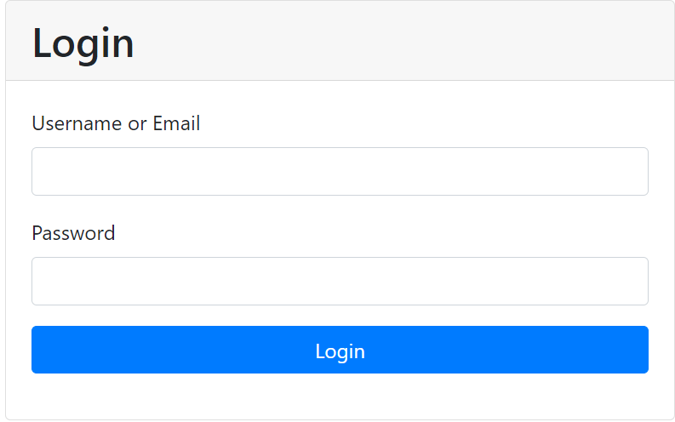

Figure 65

Registration

This function is implemented as Flask web application template for a user registration page. It allows new users to sign up for the application by providing necessary details like username, email, and password.

Key aspects include:

A form that sends data as a POST request, commonly used for transmitting user data securely.

CSRF protection via {{ form.hidden_tag() }}, which generates a hidden form field with a validation token.

Form fields for the user's username, email, password, and a confirmation password field, all rendered with HTML classes for styling.

Error handling that displays any validation errors related to each of these fields.

A submit button to send the form data to the server.

A conditional statement that checks if a user is already logged in, and if so, provides a link to the login page.

Here's a detailed explanation of how it works:

1. `{% extends "base.html" %}`: This is Jinja2 template inheritance. The code within the `{% block content %}` tags will replace the same block in the "base.html" template.
2. `{% block title %}` and `{% block content %}`: These are block tags in Jinja2, which are placeholders for content that will be inserted when the template is rendered. The `title` block defines the title of the webpage, and the `content` block contains the main content of the webpage.
3. `<form method="POST">`: This creates a form where the data will be sent to the server as a POST request. POST is a request method supported by HTTP used to send data to a server.
4. `{{ form.hidden_tag() }}`: This is a security feature in Flask-WTF that prevents cross-site request forgery. It creates a hidden field in the form that includes a token that is used to verify that the form data came from the correct site.
5. `{{ form.username.label }}` and `{{ form.username }}`: These render the label and the input field for the username, respectively. Similar lines are used for the email and password fields.
6. `{% for error in form.username.errors %}`: This is a for loop that iterates over any validation errors for the username field and displays them on the page. Similar loops are used for the email and password fields.
7. `{{ form.submit }}`: This creates a submit button for the form.
8. `{% if session.get('username') %}`: This is a conditional statement that checks if a user is already logged in. If they are, a message is displayed indicating that they can log in directly instead of registering again.

This is the front-end part of the registration process, and the actual registration (storing user data and creating a new user session) would be handled server-side. Same as the login function, the users’ data are stored with a database system.

Verification

Using registration page as an example:

In the registration template, various verifications are performed to ensure that the data entered by the user is valid. Here's how they work:

1. CSRF Protection: `{{ form.hidden_tag() }}` provides CSRF (Cross-Site Request Forgery) protection. It generates a hidden form field that includes a token. This token is used to verify that the form data was sent from the correct site. This is a security measure to prevent attackers from tricking a user into performing actions they didn't intend to.
2. Field Validation: Each form field (username, email, password, and confirm_password) is likely to have validation rules defined in the form's class on the server-side script. These rules could check, for instance, that the username doesn't already exist in the database, that the email is in the correct format, or that the password meets certain complexity requirements.
3. Error Handling: If any field fails its validation checks, an error message is added to the form field's `errors` list. These errors are then displayed to the user. For example, `{% for error in form.username.errors %}` loops over all the errors in the 'username' field, and for each error, it generates a div with an alert class, which displays the error message.
4. Password Confirmation: The form also includes a `confirm_password` field. The server-side script would typically include a validation check to ensure that the `password` and `confirm_password` fields match. If they don't, an error would be added to the `confirm_password.errors` list and displayed to the user.

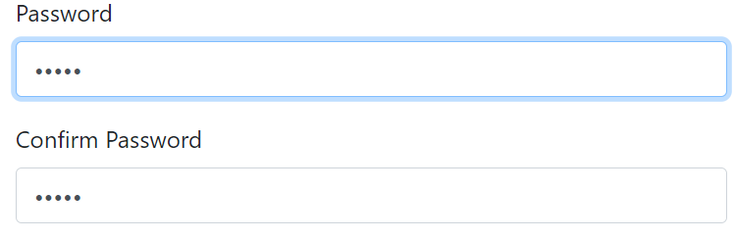

Figure 66

1. Session Check: Lastly, the `{% if session.get('username') %}` conditional checks if a user is already logged in. If they are, it displays a message indicating that they can log in directly instead of registering again. This isn't exactly a verification function but is a convenient feature for users.

Validation

Advantages of validation

* Data Quality: Validation is essential for ensuring that the data collected and processed is clean, correct, and useful. It helps maintain accuracy, completeness, and consistency in the dataset.
* Security: Validation helps to prevent security vulnerabilities. It checks inputs and can prevent harmful or malicious data, such as SQL injection or scripted attacks, from being entered into the system.
* User Experience: Client-side validation provides instant feedback to the user, allowing them to correct any errors before submitting a form. This enhances the overall user experience.
* Error Prevention: Data validation enables early detection of errors before they propagate into later stages of data processing. This not only makes the system robust but also simplifies debugging and fixing issues.
* System Efficiency: By rejecting bad or incorrect data early, validation helps avoid wastage of system resources on unnecessary processing.
* Regulatory Compliance: In certain scenarios, data validation can help ensure compliance with regulations. For example, it can validate that a field contains a properly formatted email address, or verify the user's age for age-restricted content.
* Consistent Data Entry: Validation rules enforce the specific format for data entry, ensuring consistency across the system. This is especially beneficial when multiple people or systems are entering data into a shared database.

Here is an example from my website:

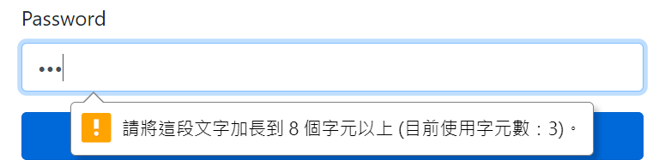

Figure 67

In login page, it will check for the length of the password to ensure the password contains at least 8 characters.

Here is another example:

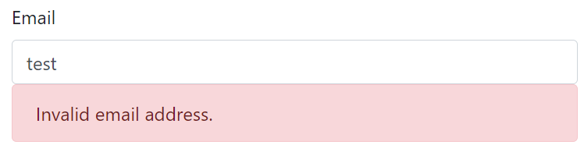

Figure 68

In registration page, format check is applied in email field to ensure the email is valid.

Admin panel functions

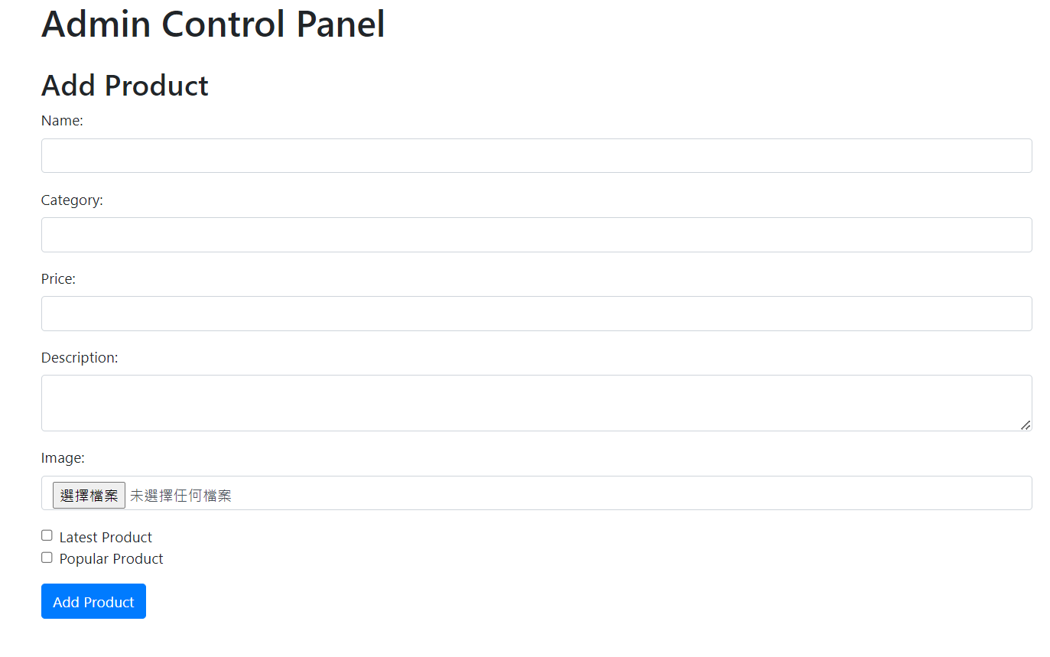

Figure 69

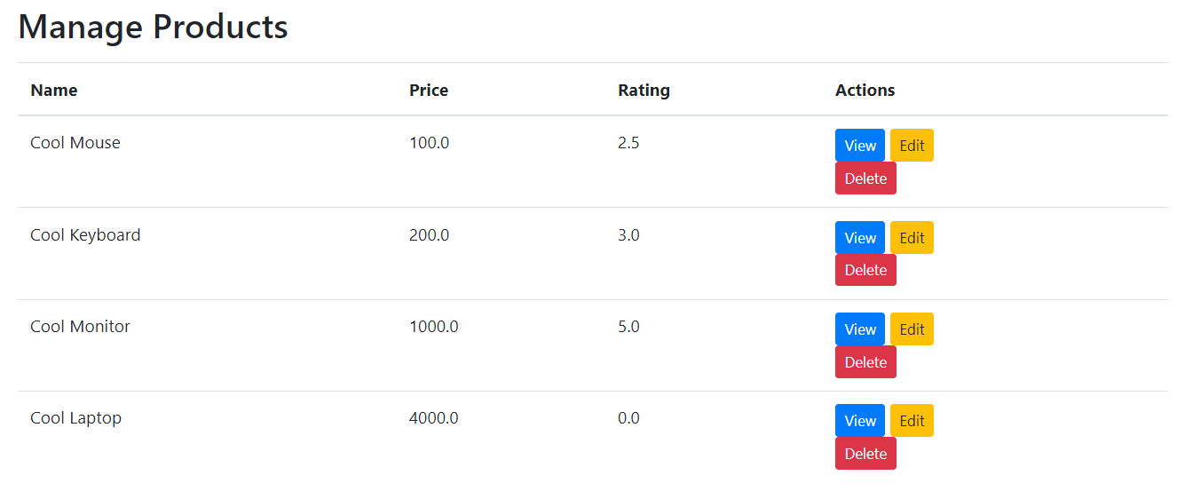

Figure 70

Admin panel is designed to streamline the process of managing products in the database, offering an intuitive user interface for adding, viewing, editing, and deleting products. This template leverages the Jinja2 templating engine and extends from a base template, allowing for code reusability and a consistent site layout.

The first notable feature of this admin panel is the "Add Product" form. This form facilitates the addition of new products to the database. Administrators can easily input product details such as name, category, price, and description. There's also an option to upload an image file for the product. Moreover, the admin can specify whether the product is a 'Latest Product' or 'Popular Product' using checkboxes. By using a form with a POST method, the data input by the admin is securely sent to the server.

Another significant feature is the "Manage Products" section, which offers a comprehensive overview of all the products in the database. Displayed in a table format, each product's name, price, and rating are clearly listed. This layout makes it simple for the admin to manage products.

Conveniently, each product listing comes with "View", "Edit", and "Delete" buttons. The "View" and "Edit" buttons link to routes that display the product details and allow for modifications, respectively. The "Delete" button implements a form that posts to a route designed to remove the product from the database. There's also a confirmation message to prevent accidental product deletion.

Comment and Rating

The comment and rating function are built using Flask and Jinja2. Here's a breakdown of the main parts:

1. Product Information: The product's image, name, description, price, and rating are displayed. There's also a button to add the product to the cart.

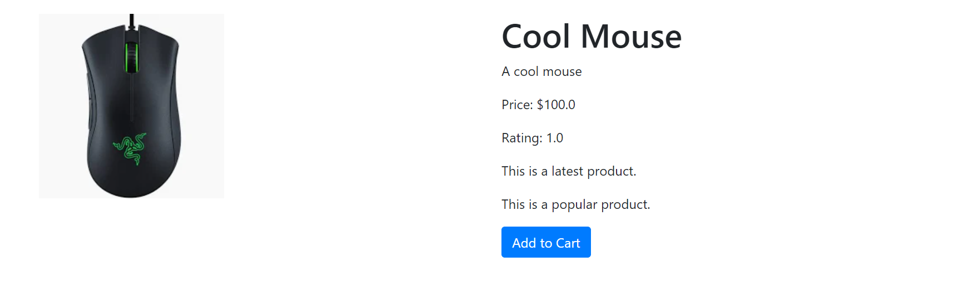

Figure 71

1. Comment Section: Each comment for the product is displayed in its own card, with the username of the commenter, their comment text, and their rating. Each rating is displayed as a series of star icons, filled in up to the rating value. If the current user is the one who left the comment, they see "Edit" and "Delete" buttons.

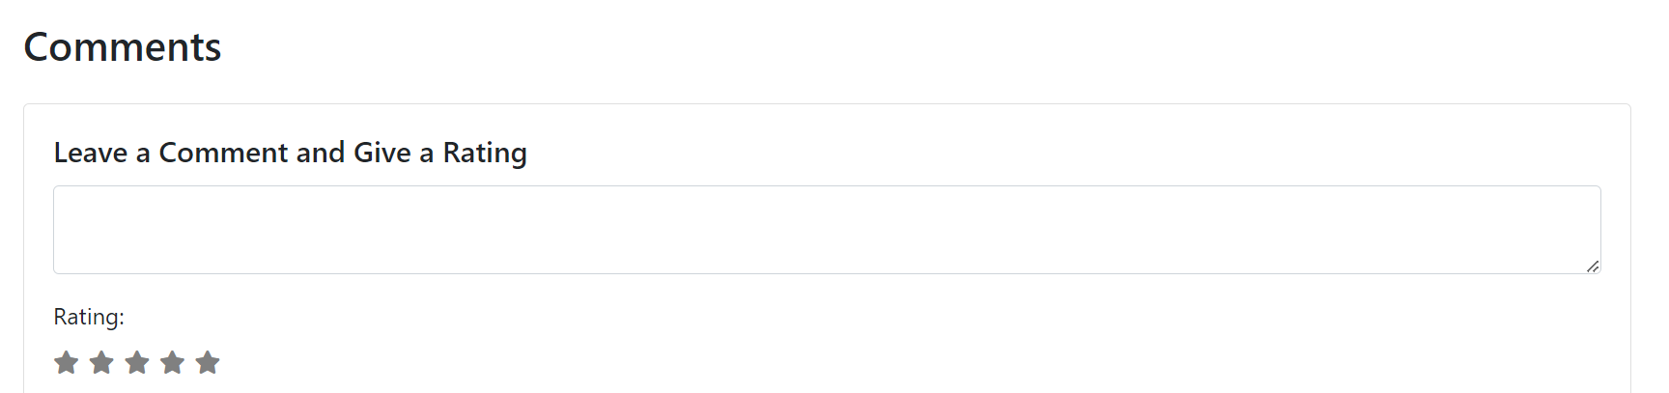

Figure 72

1. Add Comment and Rating Form: If the current user is authenticated and hasn't left a comment or rating yet, they see a form to add their own. They can leave a comment in a text box and a rating as a series of radio buttons, each represented by a star icon. When the user hovers over or clicks on a star, the stars up to that point are filled in, indicating the rating value.



After commenting and rating, the delete and edit button will show up. The form will also hide automatically.

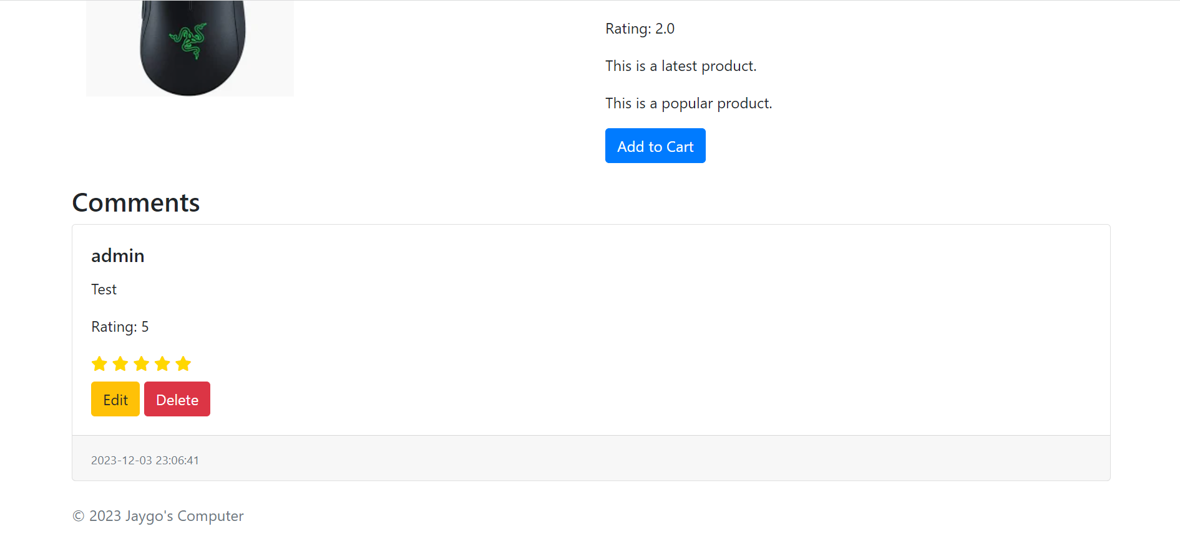

Figure 73

After click at edit button, the user will be directed to the edit comment page, which allows user to modify their comment and rating

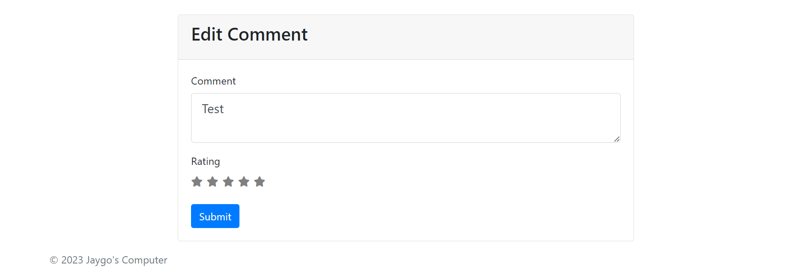

Figure 74

Code implementation:

Comment Section

1. `{% for comment in product.comments %}`...`{% endfor %}`: This loop iterates over all the comments associated with the current product.
2. `{{ comment.username }}` and `{{ comment.comment }}` display the username and the comment text of each comment.
3. `{{ comment.rating }}` shows the rating associated with the comment.
4. The nested loop `{% for i in range(5) %}`...`{% endfor %}` creates a series of five stars. If `i` is less than `comment_rating`, it displays a filled star (`fa fa-star checked`). Otherwise, it displays an empty star (`fa fa-star`).
5. If the current user is authenticated and the username matches the comment's username, the "Edit" and "Delete" buttons appear.

Add Comment and Rating Form

1. If the user is logged in (`{% if current_user.is_authenticated %}`), and neither commented nor rated (`{% if not user_commented and not user_rated %}`), a form appears allowing them to leave a comment and rating.
2. The `POST` method form contains a hidden CSRF token (`{{ form.hidden_tag() }}`), a comment text area (`{{ form.comment(class="form-control") }}`), and a rating section.
3. The rating section consists of a series of five radio buttons, each represented by a star. The user selects a rating by clicking a star. The stars get filled up to the selected rating thanks to the JavaScript code at the bottom of the template.
4. If the user is not logged in, a message is displayed asking them to log in to leave a comment or rating (`{% else %}`...`{% endif %}`).
5. The associated JavaScript code adds interactivity to the star ratings. When a star is hovered over or clicked, the stars up to that point are filled in or checked, indicating the rating value.

Shopping cart

The shopping cart page displays all the items currently in the user's cart. Each item's name, price, and quantity are displayed in a table. The total cost for each item (price times quantity) is also shown.

The quantity of each item can be updated directly within the table. The quantity field is embedded within a form, which posts to the `updatecart` route when the "Update" button is clicked. The `updatecart` route should be defined on the server side to handle the update of the item quantity in the shopping cart. The route takes a `product_id` parameter to identify which product's quantity is being updated.

Every row also includes a "Remove" button, which allows the user to remove an item from the cart. The button links to the `deletefromcart` route, which should be defined on the server side to handle the removal of the item from the cart.

The total price for all items in the cart is shown below the table.

Finally, the page includes a "Purchase" button, which links to the `payment` route. This button allows the user to proceed to the payment page to complete their purchase.

In summary, this template provides a user-friendly interface for users to view and modify their shopping cart. However, similar to the previous template, it would need to be supplemented with server-side code to handle the actual update, removal, and payment operations.

Shopping cart icon in navbar:

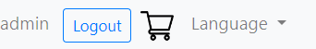

Figure 75

Remove button:



Change quantity:

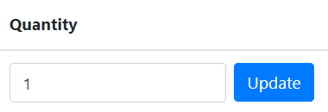

Figure 76

Price and total price:

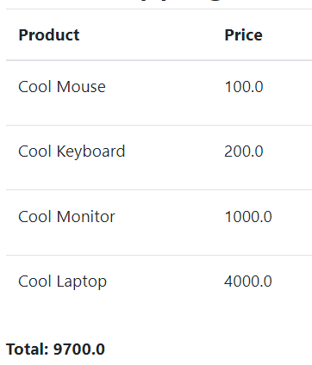

Figure 77

Payment

The payment page starts by loading jQuery, then presents a summary of the products in the user's cart. This summary is displayed in a table that lists each product's name, price, and quantity. The total price of all products is also displayed. This data is dynamically loaded by iterating over the `products` object, which is assumed to be passed to the template from the server.

After the order summary, the form for collecting customer information, shipping information, and payment details is presented. The customer information section asks for the user's name and email. The shipping information section asks for the user's address. The payment details section asks for the name on the credit card, the card number, the expiry date, and the CVV number. Each field in the form is required, and some fields have specific patterns they must match, enforced by the `pattern` attribute.

Once the user has filled out all the necessary information, they can either proceed with the payment by clicking the "Pay Now" button or go back to their shopping cart by clicking the "Back to Cart" button.

There's also a small piece of jQuery code that adds a slash ('/') after the user types two characters in the expiry date field. This improves the user experience by automatically formatting the input.

One thing to note is that this template does not handle the actual payment processing. The "Pay Now" button just links to a '/success' route, which would need to be handled on the server side, likely by integrating with a payment gateway to process the payment and update the order status.

The auto-slash function:

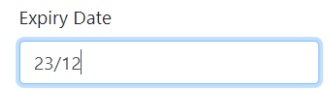

Figure 78

Different Languages

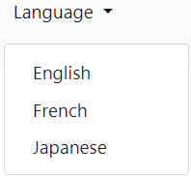

Figure 79

This function is implemented using googletrans (a python module using google translate api)

Here is an example of the page being translated into French:

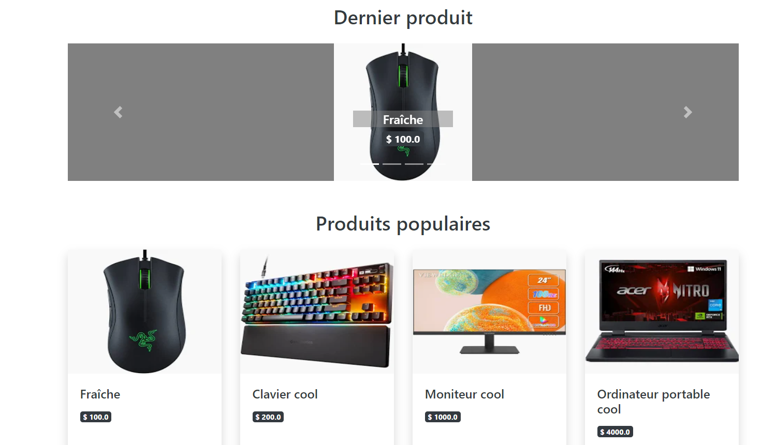

Figure 80

Offering different language options on a website has many advantages, and it can significantly enhance the user experience and broaden the site's reach.

Firstly, providing multiple language options caters to a global audience. In our increasingly interconnected world, businesses and organizations often have visitors to their websites from all around the globe. By offering content in various languages, a site can accommodate non-native English speakers and make the content more accessible to people from different linguistic backgrounds. It shows respect for cultural diversity and can help foster a more inclusive online community.

Secondly, multiple language options can drastically improve user engagement. When users can easily understand the content on a site because it's in their native language, they're more likely to stay longer, explore more, and engage more with the content. This increased engagement can lead to higher conversion rates, whether that's purchases on an e-commerce site or sign-ups on an informational platform.

Lastly, having a multilingual website can give a competitive edge in the global market. It can enhance a brand's image and expand its customer base. By breaking language barriers, businesses can reach out to potential customers who would otherwise be inaccessible. It also sends a strong signal that the business or organization values its international audience and is willing to go the extra mile to cater to their needs.

In conclusion, adding different language options to a website can significantly enhance its accessibility, user engagement, and market reach. It's a strategic move that can bring immense benefits in today's globalized digital landscape.

Database

SQLAlchemy is a popular SQL toolkit and Object-Relational Mapping (ORM) system for Python. It provides a full suite of well-known enterprise-level persistence patterns, designed for efficient and high-performing database access. It abstracts the underlying SQL commands into Python classes, functions, and methods, allowing developers to interact with databases as if they were sets of objects.

At the heart of SQLAlchemy is the ORM system, which maps Python classes to database tables, and instances of those classes (objects) to rows in their corresponding tables. It allows you to manipulate the data as Python objects, and it handles the process of translating those objects into SQL to interact with the database.

For example, instead of writing a SQL query to insert data into a table, with SQLAlchemy you would create an instance of a Python class and add it to a session. SQLAlchemy would then generate the appropriate SQL and execute it. This allows developers to work with a higher level of abstraction, focusing on the data and its interactions, rather than the specifics of SQL syntax and database engines.

SQLAlchemy also supports a wide variety of databases, including PostgreSQL, MySQL, SQLite, and others. It handles database-specific variations in SQL and provides a consistent interface across different databases, making it easier to build portable applications.

Another key feature of SQLAlchemy is its support for transactions and the ability to create complex queries using Python syntax. It provides a SQL expression language that is both flexible and allows you to use raw SQL if needed.

Example of database model using sqlalchemy

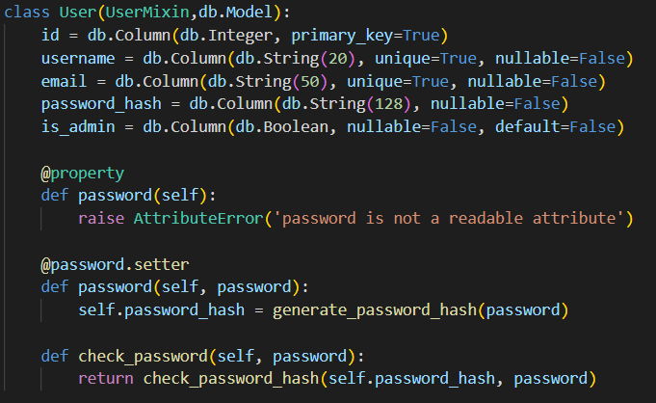

Figure 81

Codes for adding items to database

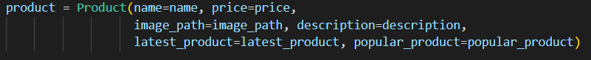

Figure 82

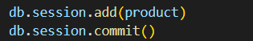

Figure 83

Most functions in this website, including login, registration, products system and many other thing have used this feature in order to store data. So the data can be sent and got from other parts in the project.

1. https://en.wikipedia.org/wiki/Online_shopping
2. https://www.statista.com/forecasts/1117851/worldwide-e-commerce-revenue-by-region
3. https://en.wikipedia.org/wiki/Customer_to_customer
4. https://en.wikipedia.org/wiki/Business-to-business
5. https://en.wikipedia.org/wiki/Types_of_e-commerce